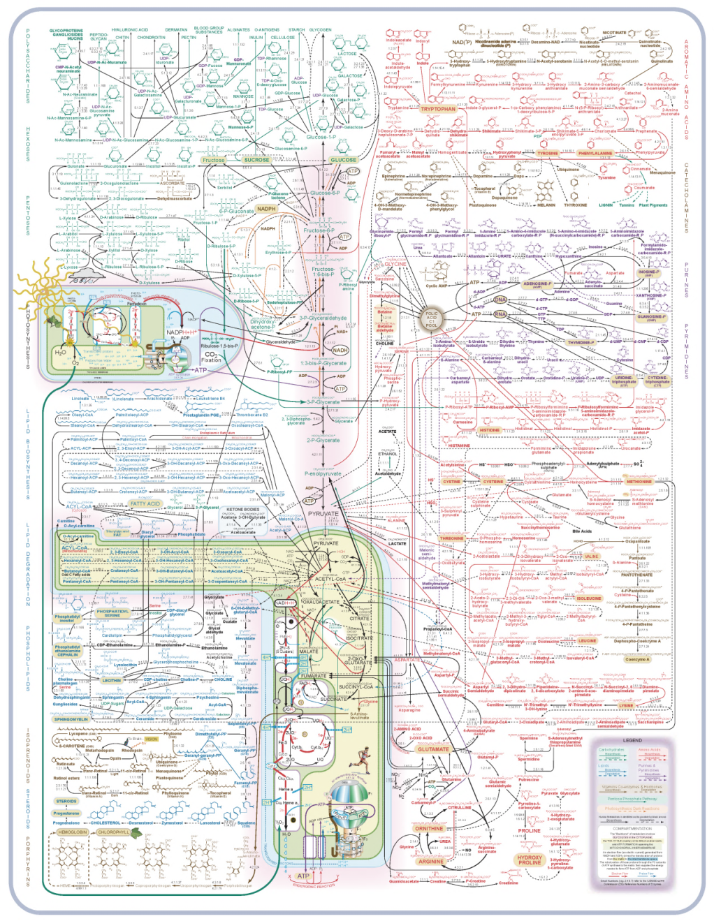

**Integrated Platform for Metabolomics Data Mining (IP4M, V1.8)**

**User Manual**

**July 25 2018**

Contents

**1. Introduction** 1

1.1 Aim and main features 1

1.2 Running environments 2

**2. Usage rules** 3

2.1 Interface structure and workflow 3

2.2 Inputs and outputs: 7

**3. Functional modules** 8

3.1 Raw data Preprocessing 8

3.1.1 LC-MS preprocessing 8

3.1.2 GC-MS preprocessing 10

3.2 Annotation by Public and Custom Libraries 14

3.2.1 GC-MS peak annotation 14

3.2.2 LC-MS peak annotation 15

3.3 Peak Table Operations 17

3.3.1 Pretreatment 17

3.3.3 Other operations 20

3.3.4 Transformation 22

3.3.5 Merge tables 23

3.4 Statistical Analysis 25

3.4.1 Univariate statistical analysis 25

3.4.2 Multivariate statistical analysis 28

3.5 Pathway Analysis 42

Tool: Compounds ID mapping 42

Tool: Pathway analysis on compounds ID mapping results 43

Tool: Enrichment analysis on compounds ID mapping results 44

3.6 Workflows 46

3.6.1 GC-MS data preprocessing workflow: from raw data to peak table 46

3.6.2 LC-MS data preprocessing workflow: from raw data to peak table 47

3.6.3 Statistical analysis based on peak table 48

3.6.4 Pathway and enrichment analysis 50

3.7 Other Tools 52

3.7.1 Merge LECO CSV files 52

3.7.2 GLM on two groups 52

3.7.3 ROC analysis 53

3.7.4 Hierarchical cluster analysis 54

3.7.5 Plot tree 56

3.7.6 Plot heatmap with tree 57

3.7.7 Sub-cluster expression analysis 57

3.7.8 Correlation and distance analysis 60

3.7.9 Plotting tools 65

3.7.10 Sample size and power analysis 68

**1. Introduction**

## 1.1 Aim and main features

Metabolomics depends more and more on bioinformatics tools, along with its rapid evolution and broad application. Currently, a number of free or commercial, desktop or web based, separate or comprehensive tools have been developed but there is still an unmet demand for a green and user-friendly desktop platform to cover all the steps of computational metabolomics. Here, an all-in-one platform for mass spectrometry-based untargeted metabolomics data mining (IP4M) was developed to provide an alternative tool for beginners and advanced users.

The main features of IP4M include the following: 1) IP4M developed using Java, Perl, and R is a freely available, green, and instrument-independent tool. 2) IP4M covers all the representative steps and functions of computational metabolomics, including peak identification and annotation, raw data and peak table preprocessing, univariate and multivariate difference analysis, correlation analysis, cluster and sub-cluster analysis, linear regression analysis, ROC analysis, pathway analysis, venn analysis, and sample size and power analysis. The integrated functions and packages are selected from numerous popular and representative ones. 3) IP4M is suitable for beginners and advanced users, as it provides workflows for a quick and reproducible analysis and offers sufficient basic/advanced parameters for a more refined analysis.

Compared with other multi-function platforms, the strengths of IP4M are the GC-MS peak identification, many simple but useful tools, and rich knowledgebase. However, it is limited in integration with other omics data. IP4M can be further extended to an online platform and NMR data preprocessing module is could be incorporated. Nevertheless, it is still an attractive alternative to existing platforms.

## 1.2 Running environments

Software: Windows 7 and above

Hardware: CPU > 3.0 GHz; Memory > 8 Gb

Programming language: Java, Perl, and R

Administrator privileges are required.

This is a green desktop software. Usually 5~10 minutes are required for initial installation and no

registration is required.

**2. Usage rules**

## 2.1 Interface structure and workflow

The software interface includes four parts: tools window, main window, task window and file window.

Workflow (Fig. 1): select a tool in tools window–> Set parameters and execute in main window –> View running status in task window –> View results in main and file window.

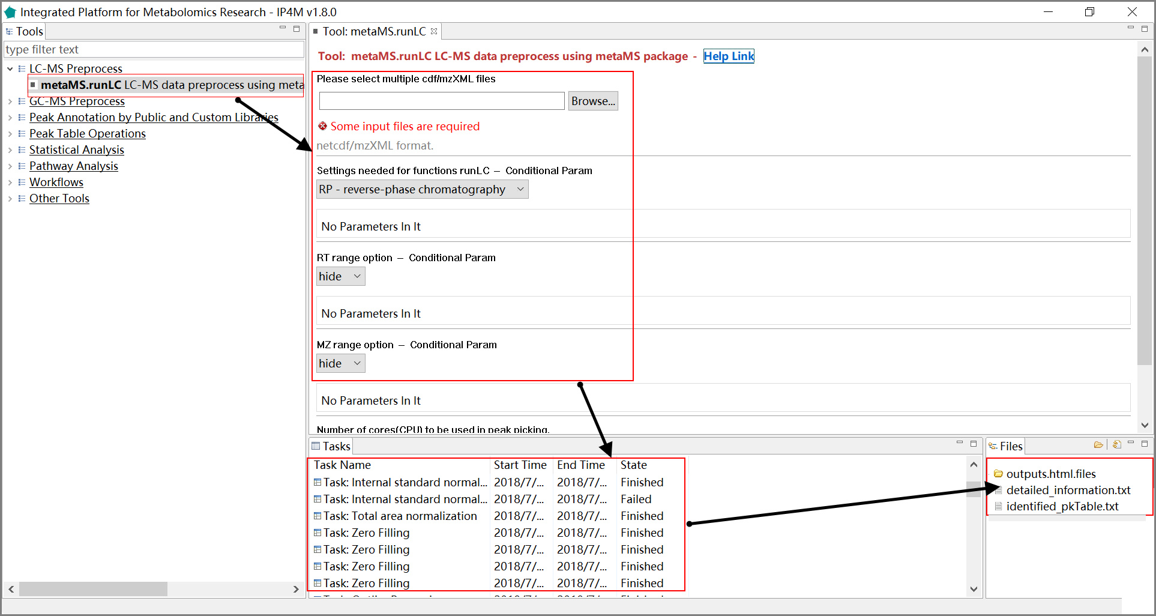

Fig.1 Workflow of usage

Specific steps:

1. In the tools window, double-click the tool you want to use and the parameters setting panel will pop up automatically (fig. 2).

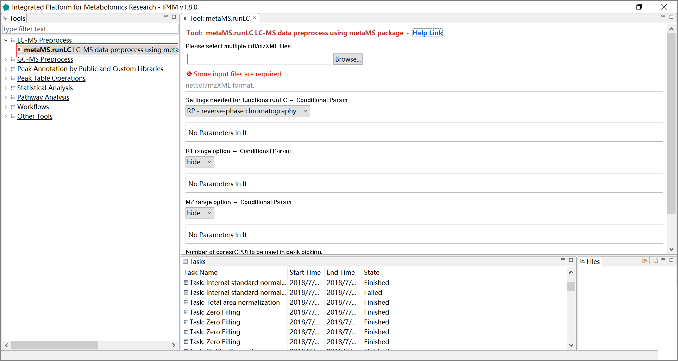

Fig.2 Select a tool

1. Use the default parameters or edit them as you want. Click the “Execute” button to run and the corresponding task information will appear in the task window (fig. 3).

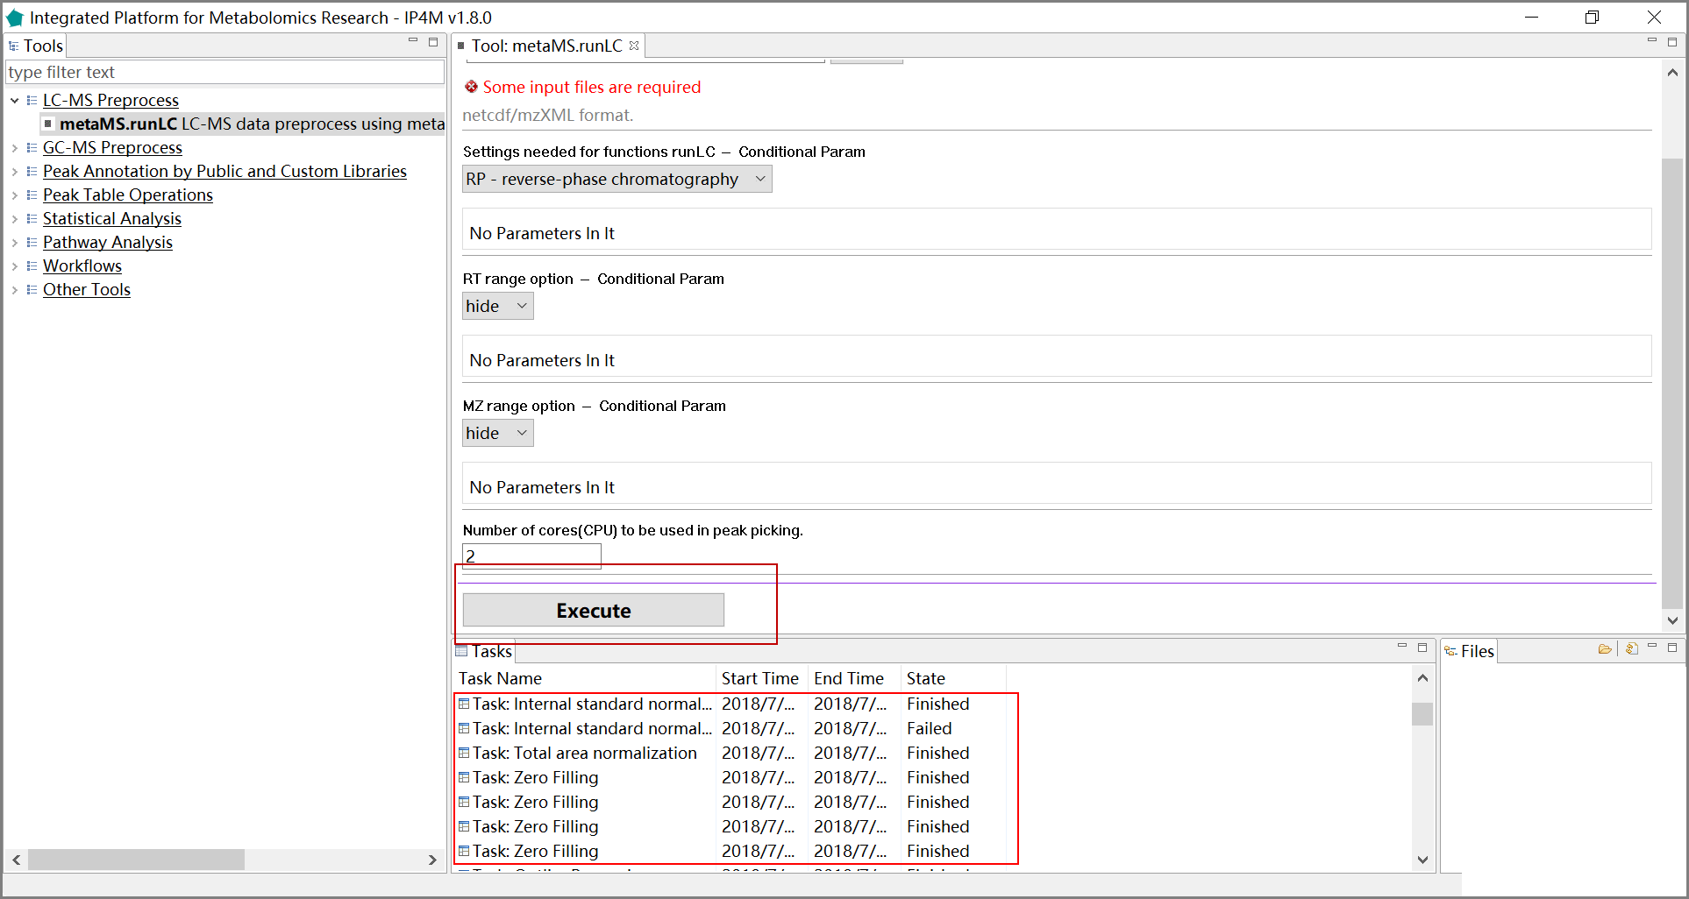

Fig.3 Execute the task

1. When the task is finished, double-click the task to view the list of result files in main window and file window. Click the files to view the specific results (Fig. 4-5).

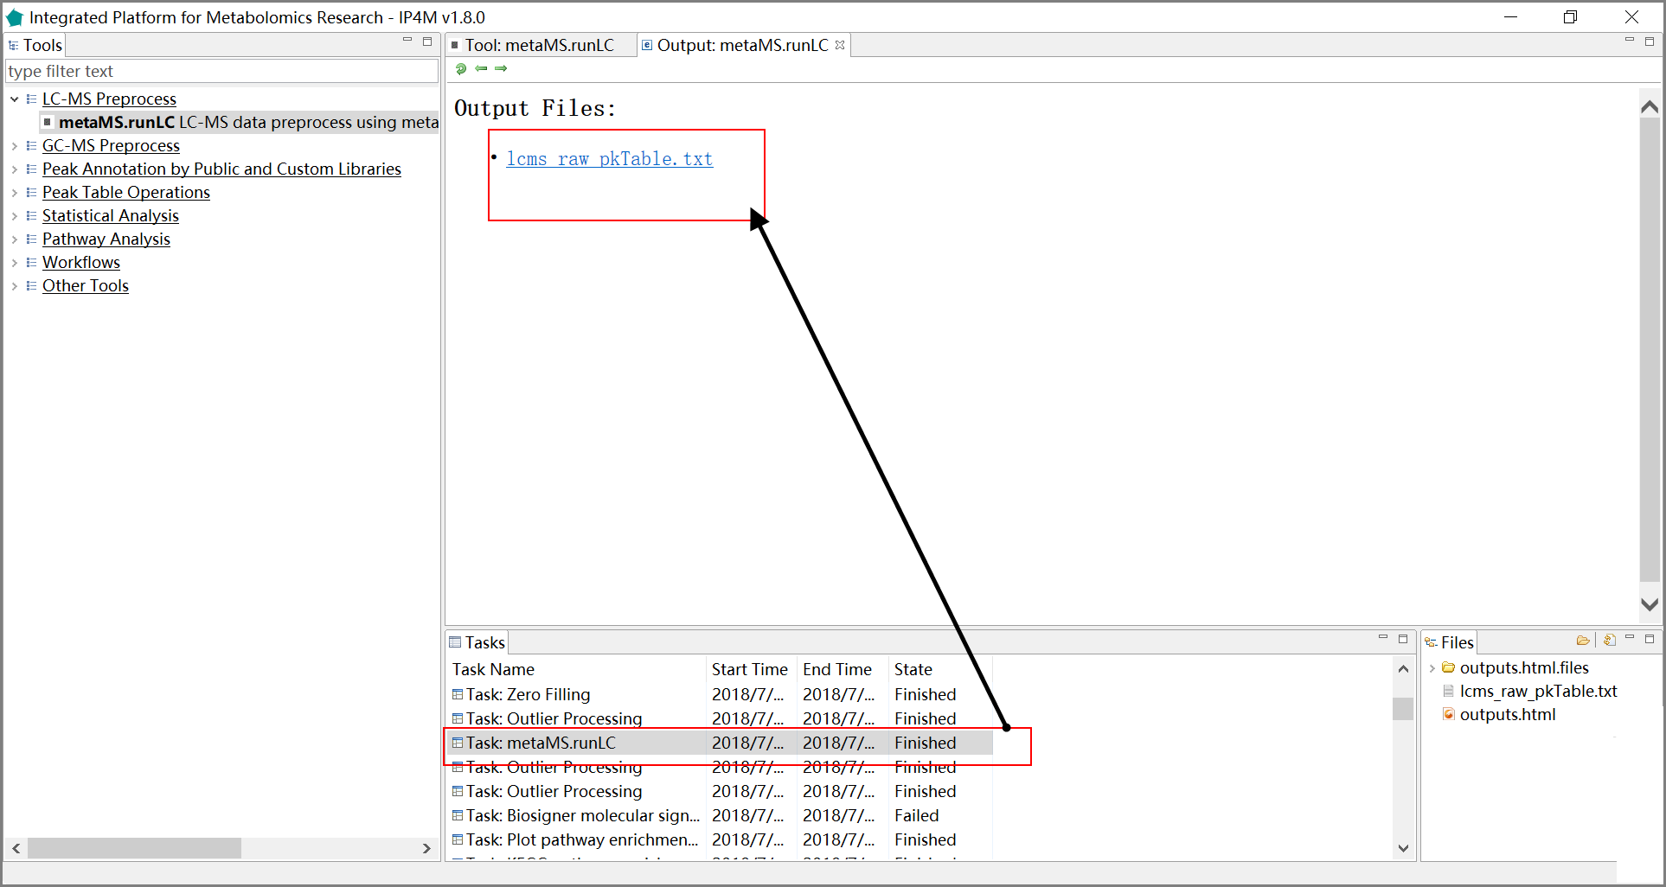

Fig.4 View the results 1

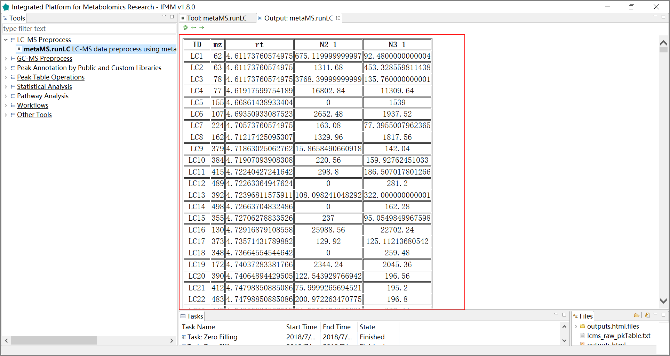

Fig.5 View the results 2

4) If the task has failed, you can double-click the task item to view the log information (fig. 6).

5) Right-click on the task item and select ‘Rerun’ to edit the inputs and/or parameters as the error messages and then re-run the task (fig. 7).

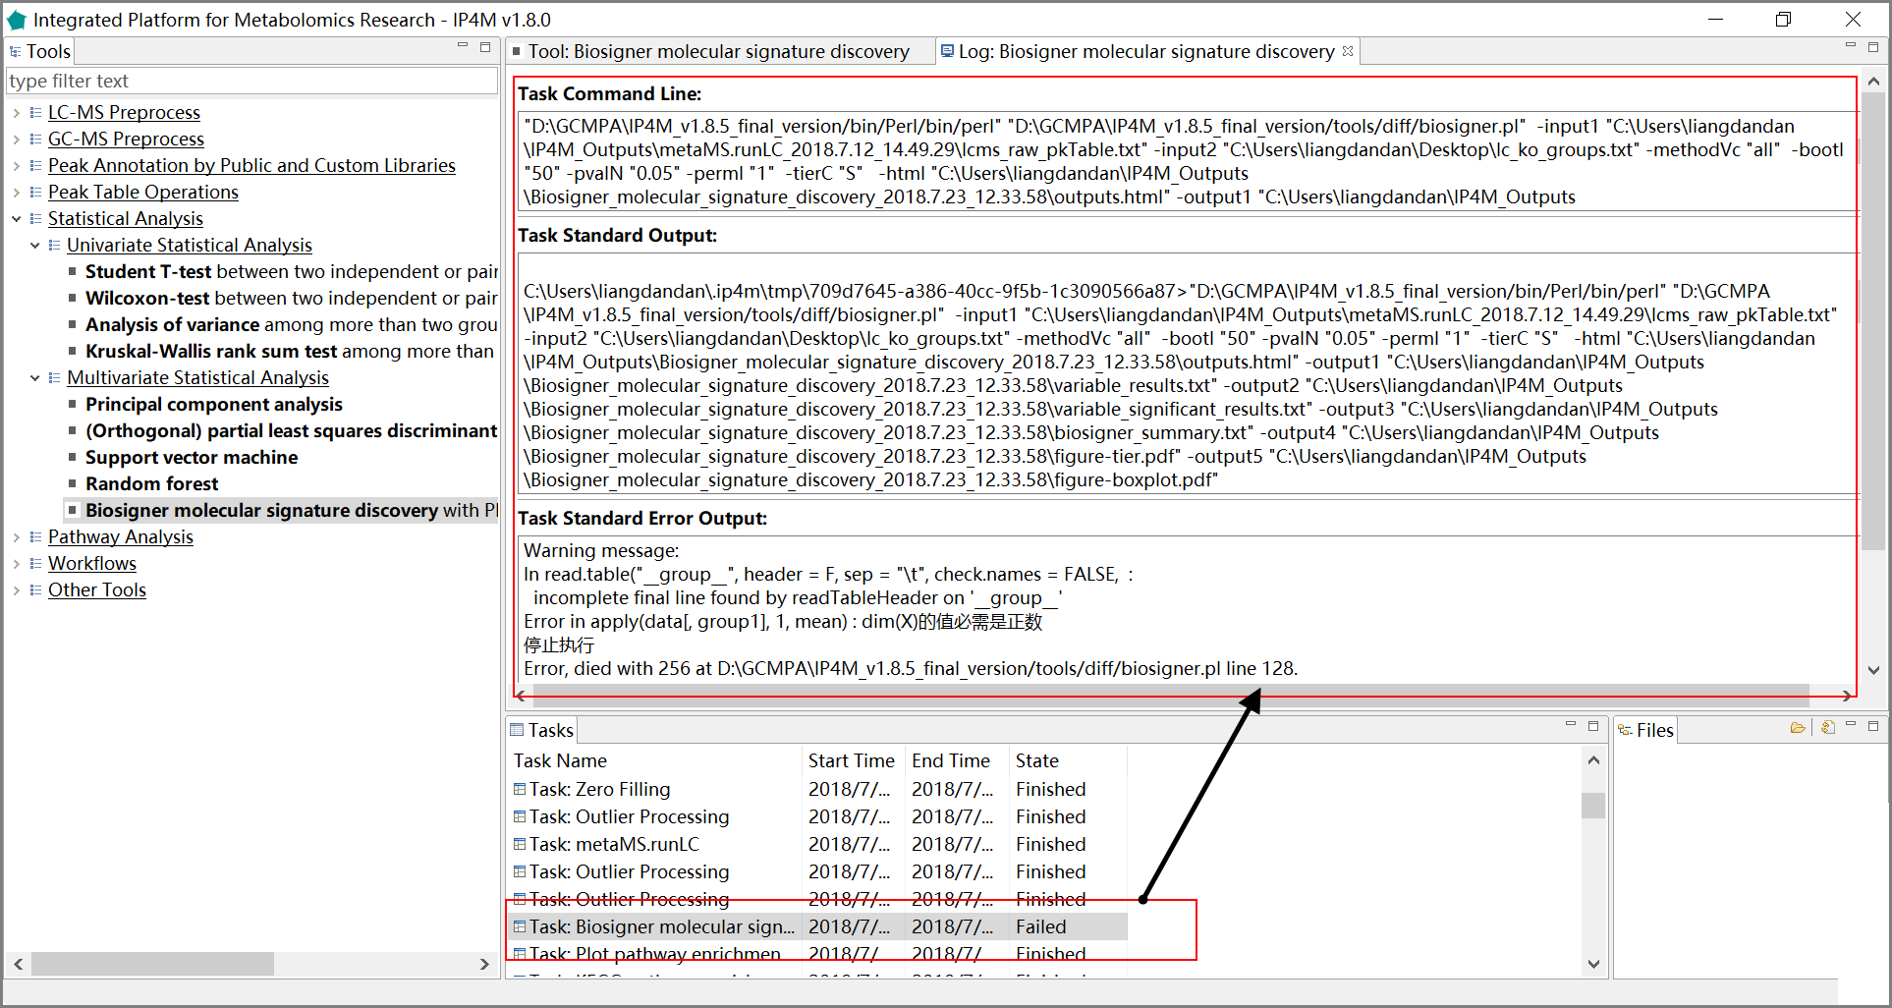

Fig.6 View the log information

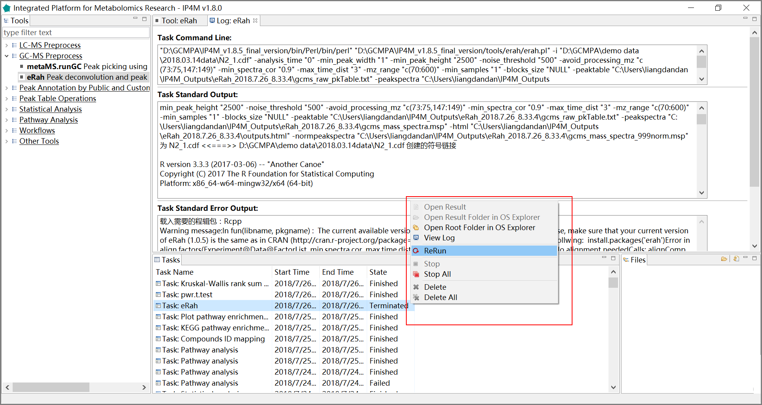

Fig.7 Rerun the task

## 2.2 Inputs and outputs:

Raw data of mzXML and NetCDF formats and other files (peak table, sample information, compound list etc.) of tab-delimited text format are supported inputs. The free software ProteoWizard (http://proteowizard.sourceforge.net/) is recommended for converting raw data files from various instrument vendors to mzXML format. All the intermediate and final results are exported as .txt files (data) or .pdf (figures) files.

**3. Functional modules**

## 3.1 Raw data Preprocessing

### 3.1.1 LC-MS preprocessing

#### Tool: metaMS.runLC LC-MS data preprocessing using metaMS package

This tool is a wrapper for the function 'runLC()' in the R 'metaMS' package. It is designed to process a series of LC-MS data files and to produce a peak table with mz, rt, and intensities of peaks in all samples. The popular package xcms is used to perform the peak picking, grouping and retention correction, and peak filling operations.

**Parameter：**

1. RP - reverse-phase chromatography: This particular setting is fine-tuned for the analysis of LC-MS runs.

2. NP - normal-phase chromatography: This particular setting is fine-tuned for the analysis of LC-MS runs.

3. RT range: RT range to process in minutes, for example, 5,25.

4. MZ range option: MZ range retained for the analysis, for example, 50,500.

5. matchedFilter: Method to use for peak detection. This function identifies peaks in the chromatographic time domain. The intensity values are binned by cutting the LC/MS data into slices (bins) of a mass unit (binSize m/z) wide. Within each bin, the maximal intensity is selected. The peak detection is then performed in each bin by extending it based on the steps parameter to generate slices comprising bins current _bin - steps +1 to current _bin + steps - 1. Each of these slices is then filtered with matched filtration using a second-derivative Gaussian as the model peak shape. After filtration peaks are detected using a signal-to-ration cut-off.

6. step size: The peak detection algorithm creates extracted base peak chromatograms (EIBPC) on a fixed step size.

7. FWHM: Full width at half maximum of matched filtration gaussian model peak. Can only be used to calculate the actual sigma.

8. max: Maximum number of peak per extracted ion chromatogram.

9. snthresh: Signal to noise ratio cutoff.

10. min. class. Fraction: Minimum fraction of sample necessary in at least one of the sample groups for it to be a valid group.

11. min. class. Size: Minimum number of sample necessary in at least one of the sample groups for it to be a valid group.

12. mzwid: Width of overlapping m/z slices to use for creating peak density chromatograms and grouping peaks across samples.

13. bws: The two bandwidths used for grouping before and after retention time alignment.

14. missing ratio: Ratio of missing samples to allow in retention time correction groups.

15. extra ratio: Ratio of extra peaks to allow in retention time correction groups.

16. centWave: Method to use for peak detection. The centWave algorithm performs peak density and wavelet-based chromatographic peak detection. It is most suitable for high-resolution LC/{TOF,OrbiTrap,FTICR}-MS data in centroid mode. In the first phase the method identifies regions of interest (ROIs) representing mass traces that are characterized as regions with less than ppm m/z deviation in consecutive scans in the LC/MS map. These ROIs are then subsequently analyzed using continuous wavelet transform (CWT) to locate chromatographic peaks on different scales. The first analysis step is skipped, if regions of interest are passed via the param parameter.

17. ppm: Numeric defining the maximal tolerated m/z deviation in consecutive scans in parts per million (ppm) for the initial ROI definition

18. peakwidth: numeric with the expected approximate peak width in chromatographic space. Given as a range (min, max) in seconds.

19. prefilter: numeric: c (k, I) specifying the prefilter step for the first analysis step (ROI detection). Mass traces are only retained if they contain at least k peaks with intensity >= I.

**Reference:**

[1] R. Wehrens, G. Weingart and F. Mattivi, metaMS: An open-source pipeline for GC-MS-based untargeted metabolomics J. Chrom. B (2014), v966, 109-116.

[2] Colin A. Smith, Elizabeth J. Want, Grace O’Maille, Ruben Abagyan and Gary Siuzdak. "XCMS: Processing Mass Spectrometry Data for Metabolite Profiling Using Nonlinear Peak Alignment, Matching, and Identification" Anal. Chem. 2006, 78:779-787.

[3] Ralf Tautenhahn, Christoph B\"ottcher, and Steffen Neumann "Highly sensitive feature detection for high resolution LC/MS" BMC Bioinformatics 2008, 9:504

**Results and visualization:**



Fig. 1 the outputted Peak table with two samples of metaMS.runLC tool

### 3.1.2 GC-MS preprocessing

#### Tool: metaMS.runGC peak picking using metaMS package

This tool is a wrapper for the function 'runGC()' in the R 'metaMS' package which is designed to process a series of GC-MS data files and to produce a peak table. It performs a pseudospectrum-based analysis, where the basic entity is a collection of (mz, I) pairs at specific retention times. The standard workflow of metaMS for GC-MS data is the following:

1. peak picking;

2. definition of pseudospectra;

3. identification and elimination of artefacts;

4. annotation by comparison to a database of standards;

5. definition of unknowns;

6. output.

**Parameter:**

1. RT range: part of the chromatograms that is to be analyzed. If given, it should be a vector of two numbers indicating minimal and maximal retention time (in minutes). For example 5, 25.

2. FWHM: numeric specifying the full width at half maximum of matched filtration gaussian model peak. Can only be used to calculate the actual sigma.

3. RT_ Diff: the allowed RT shift in minutes between different samples.

4. Min_ Features: the minimum number of ion in a mass spectrum.

5. similarity_ threshold: the minimum similarity allowed between mass spectra considered as the same compound.

6. min. class. fract: the fraction of samples in which a pseudospectrum is present before it is regarded as an unknown.

7. min. class. size: the absolute number of samples in which a pseudospectrum is present before it is regarded as an unknown.

**Reference:**

[1] R. Wehrens, G. Weingart and F. Mattivi, metaMS: An open-source pipeline for GC-MS-based untargeted metabolomics J. Chrom. B (2014), v966, 109-116.

**Results and visualization:**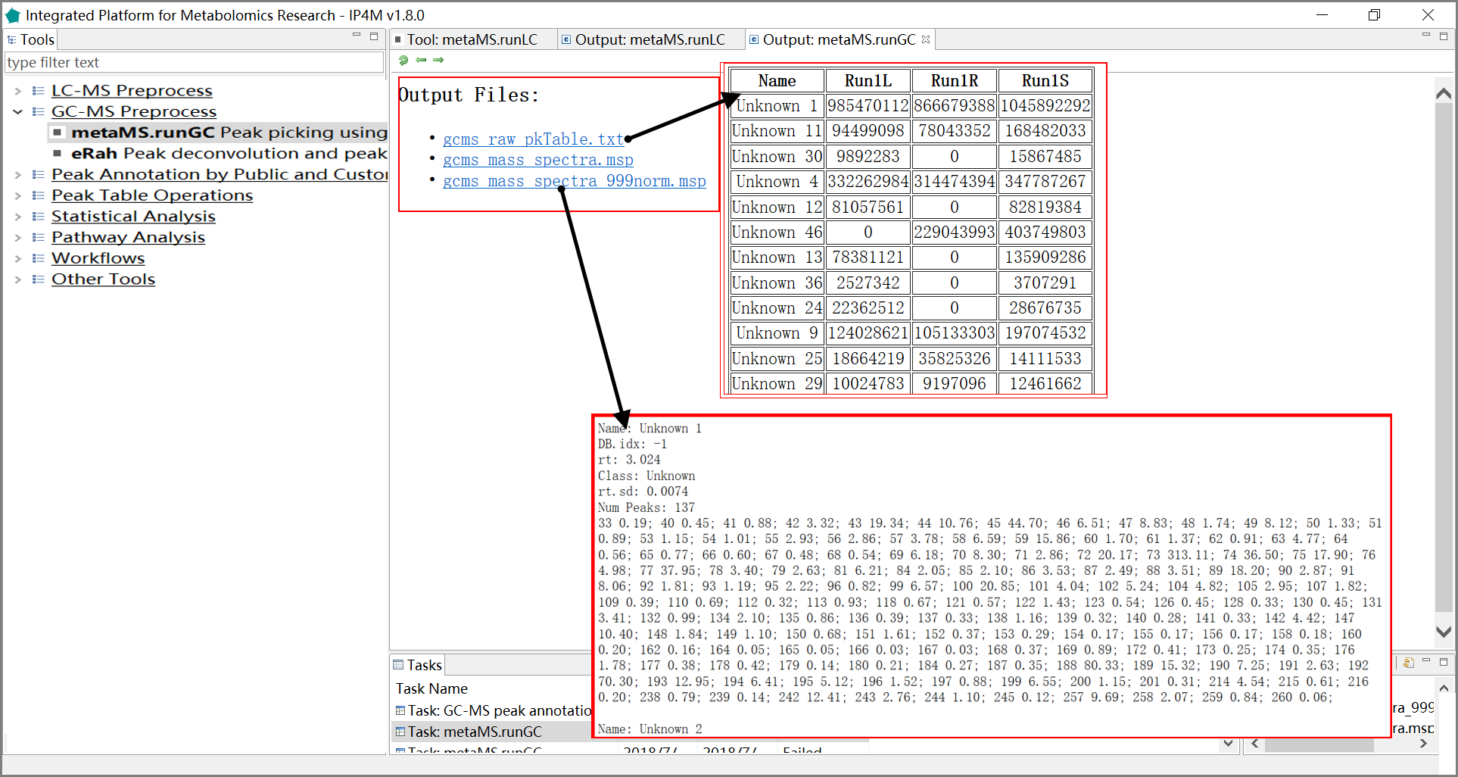

Fig.2 The outputted total results files, peak table, and normalized mass spectra information of metaMS.runGC.

#### Tool: eRah Peak deconvolution and peak picking using eRah package

This tool is a wrapper of the R 'eRah' package for GC-MS data processing. 'eRah' is an R package that allows for an innovative deconvolution of GC-MS chromatograms using multivariate techniques based on blind source separation (BSS). It automatically detects and deconvolves the spectra of the compounds appearing in GC-MS chromatograms. Then, compounds are aligned by spectral similarity and retention time distance. It computes the Euclidean distance between retention time distance and spectral similarity for all compounds in the chromatograms, resulting in compounds appearing across the maximum number of samples and with the least retention time and spectral distance. After that, a missing compound recovery step can be applied to recover those compounds that are missing in some samples. Missing compounds appear as a result of an incorrect deconvolution or alignment - due to a low compound concentration in a sample - , or because it is not present in the sample. This forces the final data table with compound names and compounds area, to not have any missing (zero) values. Please see the references for detailed descriptions.

**Parameter：**

1. RT window: The chromatographic retention time window to process. If 0 all the chromatogram is processed.

2. Minimum peak width: This is a critical parameter that conditions the efficiency of eRah. Typically, it should be the half of the mean compound width.

3. noise. threshold: Data above this threshold will be considered as noise

4. avoid.processing.mz: The masses that do not want to be considered for processing. Typically, in GCMS those masses are 73,74,75,147,148 and 149, since they are ubiquitous mass fragments typically generated from compounds carrying a trimethylsilyl moiety.

5. Minimum spectral correlation value: From 0 (no similar) to 1 (very similar). This value sets how similar two or more compounds have to be considered for alignment between them.

6. Maximum retention time distance: This value (in seconds) sets how far two or more compounds can be considered for alignment between them.

7. Minimum. sample: The minimum number of samples in which a compound has to appear to be considered for searching into the rest of the samples where this compound is missing.

8. blocks. size: For experiments containing more than 100 (Windows) or 1000 (Mac or Linux) samples (numbers depending on the computer resources and sample type). In those cases, alignment can be conducted by block segmentation. For an experiment of e.g. 1000 samples, the block.size can be set to 100, so the alignment will perform as multiple (ten) 100-samples experiments, to later align them into a single experiment.

This parameter is designed to solve the typical problem that appears when aligning under the Windows operating system: "Error: cannot allocate vector of size XX Gb". Such a problem will not appear with Mac or Linux, but several hours of computation are expected when aligning a large number of samples. Using block segmentation provides a greatly improved run-time performance.

**Reference:**

[1] X. Domingo-Almenara, et al., eRah: a computational tool integrating spectral deconvolution and alignment with quantification and identification of metabolites in GC{MS-based metabolomics. Analytical Chemistry. 88 (2016) 9821{9829. DOI: 10.1021/acs.analchem.6v02927

[2] X. Domingo-Almenara, et al., Compound identification in gas chromatography/mass spectrometry-based metabolomics by blind source separation. Journal of Chromatography A 1409 (2015) 226{233. DOI: 10.1016/j.chroma.2015.07.044

**Results visualization:**

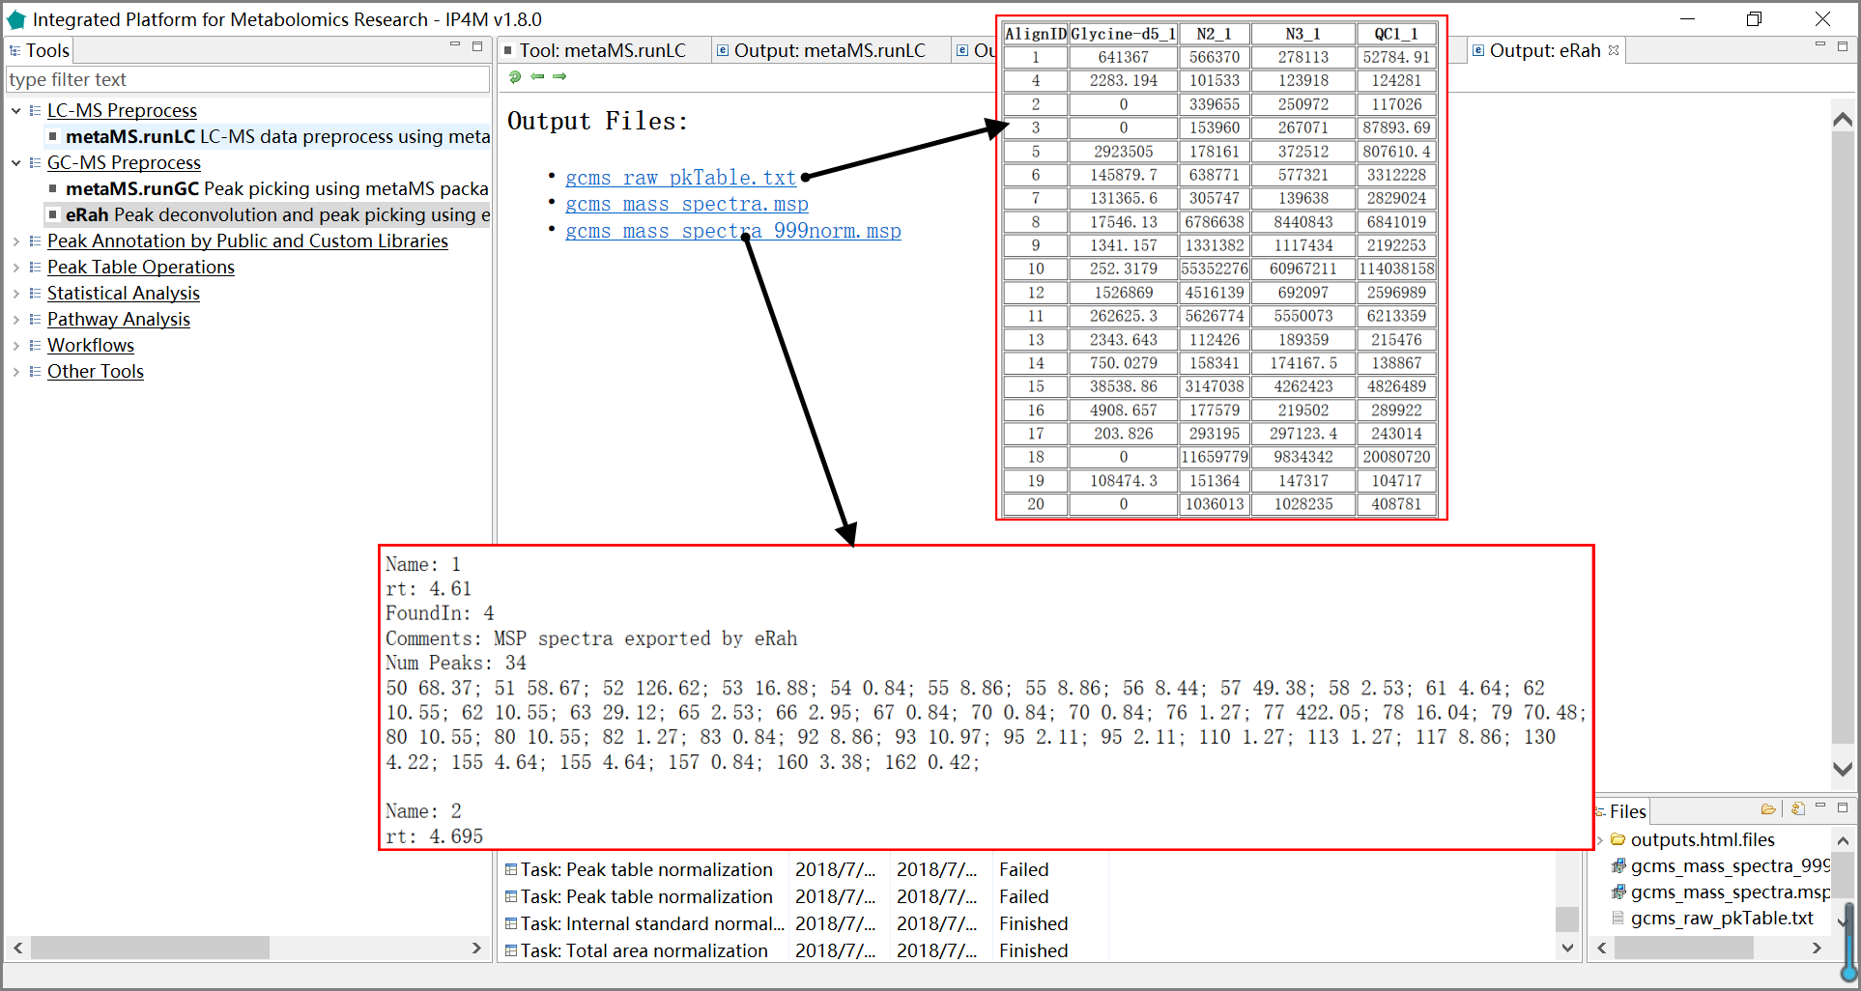

Fig.3 The outputted results files, peak table, and normalized mass spectra of eRah package.

## 3.2 Annotation by Public and Custom Libraries

### 3.2.1 GC-MS peak annotation

#### Tool: GC-MS peak annotation on msp database files

This tool intends to annotate compounds from the GC-MS peak table by matching mass spectra and/or retention times of public/custom library and detected peaks. If you want to use the custom library for annotation, a standard MSP format file is required.

**Parameter:**

1. normalized dot product: Matching factor function for mass spectrum. The function applies weights to an input to get weighted outputs.

2. normalized Euclidean distance: Matching factor function for mass spectrum.

3. mass spectrum similarity cutoff: 0-1, more similar larger matching factor.

4. RT window: The retention time difference that can be allowed.

5. NSEN: An integrated library derived from NIST/EPA/NIH. It is the default public library.

6. GMD_ALK: A public database from the Golm Metabolome Database (GMD). ALK - based on 9 n-alkanes (C10–C36).

7. GMD_FAME: A public database from the Golm Metabolome Database (GMD). FAME - based on 13 fatty acid methyl esters (C8 ME–C30 ME).

8. GMD_MSIR: The 'Q_MSRI_ID' GC-Quadrupole-MS MSRI Database of Golm Metabolome library.

9. MoNA-HMDB: It is derived from MassBank of North America, with 4620 spectra(http://mona.fiehnlab.ucdavis.edu/downloads).

10. MoNA-MetaboBASE: It is derived from MassBank of North America, with 1254 spectra (http://mona.fiehnlab.ucdavis.edu/downloads).

11. MoNA-ReSpect: It is derived from MassBank of North America, with 6290 spectra(http://mona.fiehnlab.ucdavis.edu/downloads).

**Note:**

There is no retention time field in the public library and only mass spectrum information is used for annotation. For a custom library, this tool supports the joint annotation by mass spectrum and retention time. Users can provide an in-house library file in MSP format containing the field 'rt'. This is an optional field. A compound can be repeated in the database with the same 'Name ' but a different mass spectrum. In this case, the best hit will be outputted.

**Reference:**

[1] Schauer N, Steinhauser D, Strelkov S, Schomburg D, Allison G, Moritz T, Lundgren K, Roessner-Tunali U, Forbes MG, Willmitzer L, Fernie AR, Kopka J: GC-MS libraries for the rapid identification of metabolites in complex biological samples. FEBS Lett 2005, 579(6):1332–1337. 10.1016/j.febslet.2005.01.029

[2] Kopka, J., Schauer, N., Krueger, S., Birkemeyer, C., Usadel, B., Bergmuller, E., Dormann, P., Weckwerth, W., Gibon, Y., Stitt, M., Willmitzer, L., Fernie, A.R. and Steinhauser, D. (2005) GMD@CSB.DB: the Golm Metabolome Database, Bioinformatics, 21, 1635-1638.

**Results and visualization:**

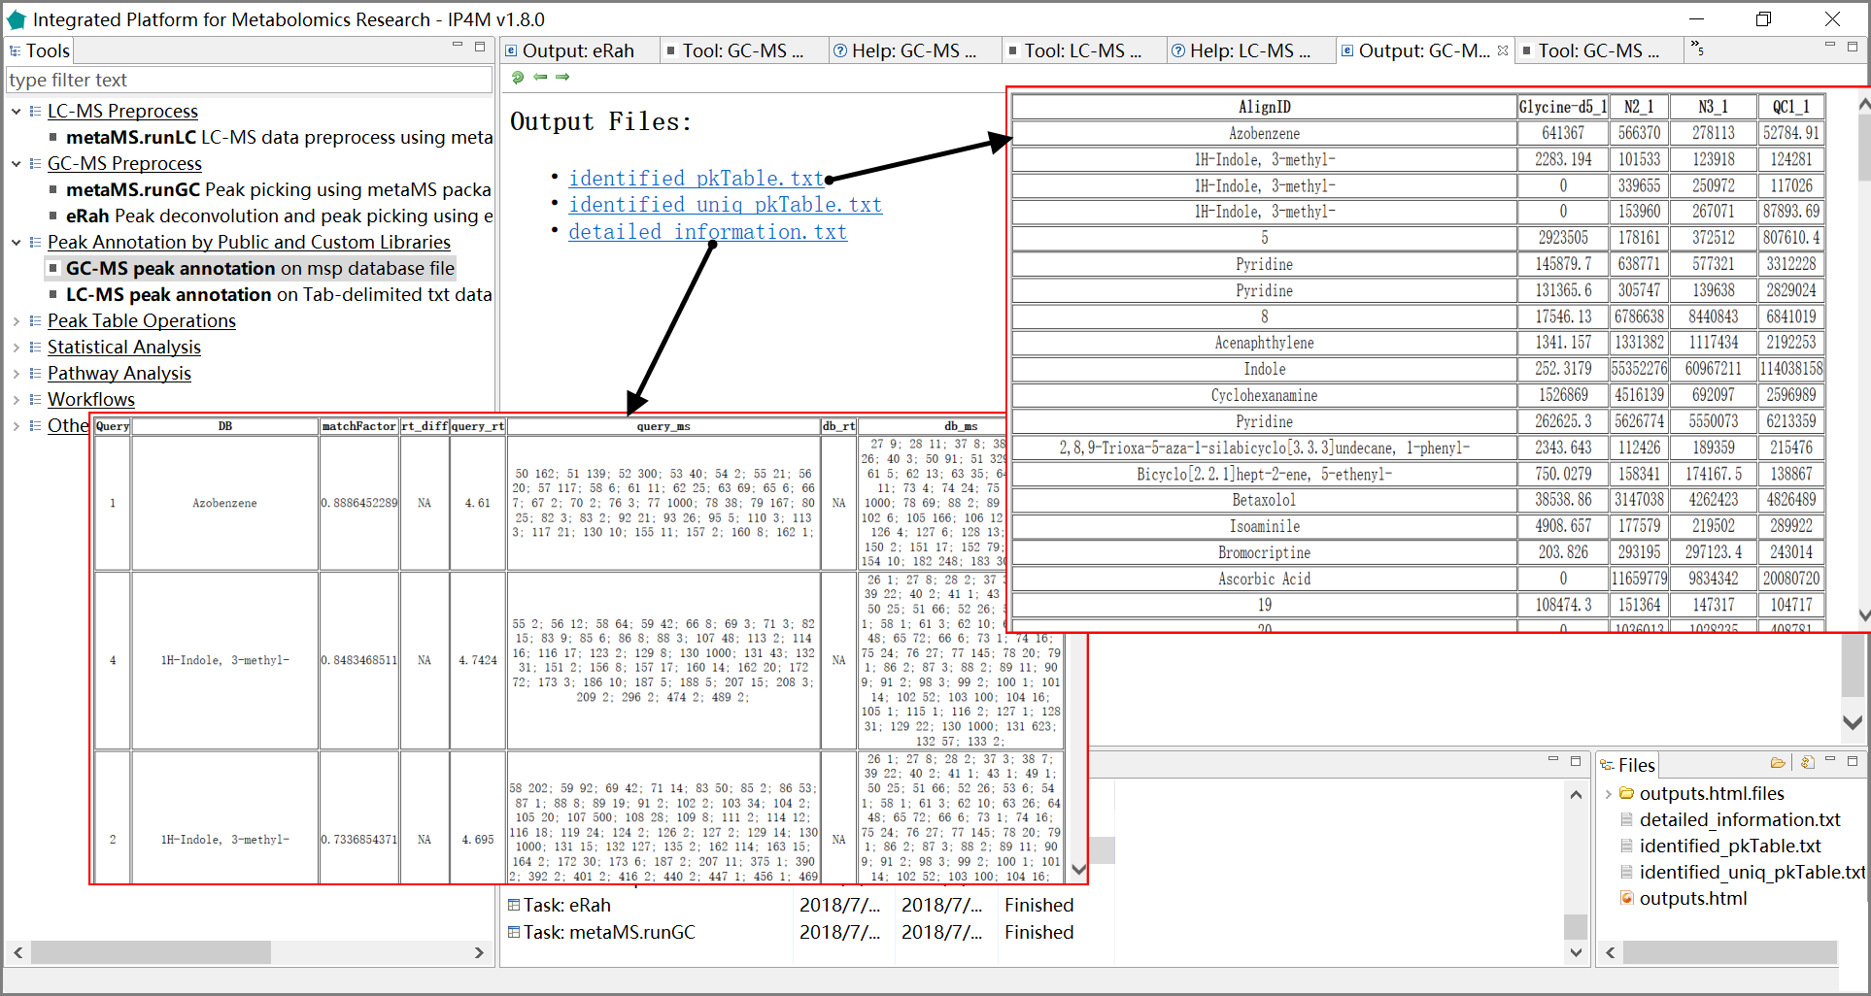

Fig.4 The outputted total files, identified peak table, and compounds detailed information of GC-MS peak table annotation.

### 3.2.2 LC-MS peak annotation

#### Tool: LC-MS peak annotation on xls database files

This tool is used to annotate compounds from the LC-MS peak table by comparing m/z and RT with the public/custom library. The best top five hits will be shown in the results. If you want to use the custom library for annotation, a two-column Tab-delimited text file is required with the first column as compound name and the second column as precise MZ.

**Parameter:**

1. mz cutoff: A hit that difference of mz must be <=mz_cutoff.

2. RT window: The acceptable retention time difference.

3. ppm: Parts per million. numeric the relative error for matching peaks that is a window of user specified error (or the default 10) in ppm for each fragment mass.

(|M- M0|÷m) ×106 (ppm). ‘M’ is the measured value of the ion mass; ‘M0’ is the theoretical value of the ion mass; ‘m’, an integer, is the mass of the ion.

For example, the molecular ion measured value of a compound is 364.2504, the theoretical value is 364.2509, and the mass measurement accuracy is: |364.2504-364.2509|÷364×106=1.4ppm

4. adducts type: There are several possible adducts and the recommended type that most commonly occurs is “M+H” or “M-H”.

**Note:**

1. There is no retention time field in the public library and only mass spectrum information is used for annotation. For a custom library, this tool supports the joint annotation by precise MZ and retention time. Users can provide an in-house two-column Tab-delimited text file with the first column as compound name and the second column as precise MZ.

2. The tool will identify all possible matching compounds based on all adduct types selected, sort them according to the matching score, and output them all as 'detailed_information.txt'. Also, the compound with the smallest MZ and RT deviation will be outputted as the final identified compound in 'identified_pkTable.txt' file.

**Results and visualization:**

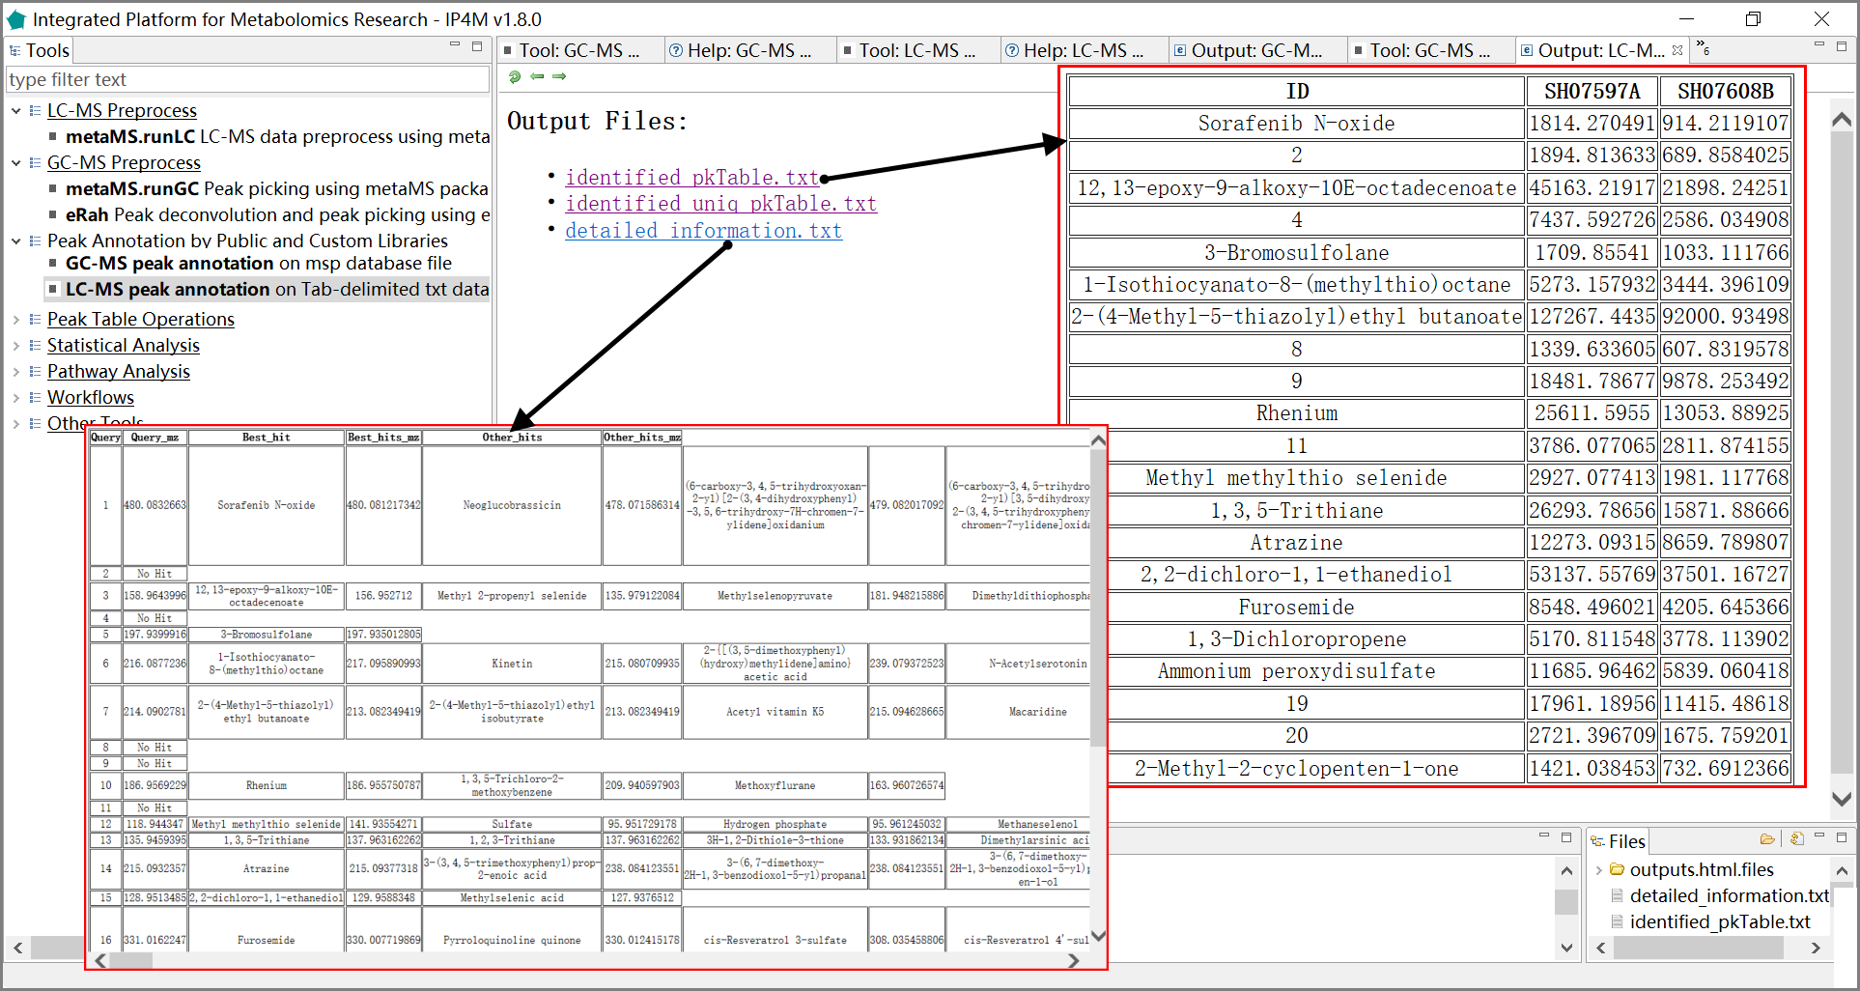

Fig.5 The outputted results files, identified peak table, and detailed information of compounds of LC-MS peak annotation.

## 3.3 Peak Table Operations

### 3.3.1 Pretreatment

#### Tool: Outlier processing on peak table

The tool takes a peak table file as input and processes the outliers using the capping method. Default boundary is [0, Q3+1.5*IQR]. If the value > (Q3+1.5*IQR), it is identified as an outlier and replaced by the maximum value within the normal range.

**Parameter:**

1. Q3: The third quartile (Q3), also known as the "larger quartile", equals to the value ranked at 75% of all values in ascending order.

2. IQR: InterQuartile Range, equals to |Q3 minus Q1|.

#### Tool: Zero filling on peak table

This tool takes a peak table file as input and fills the missing values (zero , null value or ‘NA’, or negative values) with 1) the a*min value, where 'a' is a user-defined coefficient; 2) 'min' which is the minimum non-negative value in the peak table; 3) user-specified value; 4) values computed by 'KNN'; and 5) values computed by 'qirlc'. The ‘qirlc’ algorithm is especially suitable for left-censored data.

**Reference:**

If you use 'KNN' method, references:

[1] Hastie, T., Tibshirani, R., Sherlock, G., Eisen, M., Brown, P. and Botstein, D., Imputing Missing Data for Gene Expression Arrays, Stanford University Statistics Department Technical report (1999).

[2] Olga Troyanskaya, Michael Cantor, Gavin Sherlock, Pat Brown, Trevor Hastie, Robert Tibshirani, David Botstein and Russ B. Altman, Missing value estimation methods for DNA microarrays BIOINFORMATICS Vol. 17 no. 6, 2001 Pages 520-525

If you use 'qirlc' method, references:

[3] QRILC: a quantile regression approach for the imputation of left-censored missing data in quantitative proteomics, Cosmin Lazar et al.

[4] Wei R, Wang J, Su M, et al. Missing Value Imputation Approach for Mass Spectrometry-based Metabolomics Data: [J]. Scientific Reports, 2018, 8(1).

[5] Wei R, Wang J, Jia E, et al. GSimp: A Gibbs sampler based left-censored missing value imputation approach for metabolomics studies: [J]. Plos Computational Biology, 2018, 14(1):e1005973.

#### 3.3.2 Normalization

#### Tool: Total area normalization on peak table

This tool takes a peak table file as input and performs total intensity normalization within samples. The formula is (x/sum of total intensity within the corresponding sample) *1000.

#### Tool: Internal standard normalization

This tool takes a peak table file as input and performs internal standard (IS) normalization within samples. The normalization formula is (x/internal standard) *10000.

**Parameters:**

Set the standard compound: for example Chlorophenylalanine

**Note:**

1. The IS compound must exist in the inputted peak table.

2. Experimental preparation: The internal standard must be prepared in advance and added quantitatively to each sample.

#### Tool: Peak table normalization based on QC (pooled samples)

This tool takes a peak table file as input and performs normalization based on quality control samples (QCs).

QCs are pooled samples. They contain the same compounds as the subject samples and are supposed to reflect the average metabolite concentrations within a study. QCs are pretreated according to the same protocols as the subject samples and are evenly injected throughout the analyses. The performances of the pretreatment and the analytical platform can be assessed using the QCs. The normalization formula is (x metabolite/QC metabolite) *10000.

**Input files:**

1. Peak table file in Tab-delimited text format, with the first column as the compound identifier and others as samples.

For example:

Table.1 Peak table with QC

|  |  |  |  |  |  |
| --- | --- | --- | --- | --- | --- |
| AlignID | STDmix_GC_01 | STDmix_GC_02 | QC1 | STDmix_GC_03 | QC2 |
| Unknown 1 | 1486892478 | 561322777 | 3448620272 | 3448620272 | 561322777 |
| Nitrogen dioxide | 5492977592 | 684434115 | 3265669981 | 3265669981 | 3265669981 |
| Ethanol, 2-fluoro- | 2265686433 | 4182838129 | 4365291513 | 4365291513 | 4182838129 |
| 3-Pentanone, 2,2,4,4-  tetramethyl- | 13390154 | 12612932 | 21155307 | 21155307 | 21155322 |
| Hydrazine | 14588107 | 8510918 | 7224351 | 7224351 | 7224380 |
|  |  |  |  |  |  |

1. Sample-to-QC design file, a Tab-delimited text file with two columns, "sample" and "QC".

For example:

Table.2 Sample-to-QC group file

|  |  |
| --- | --- |
| STDmix_GC_01 | QC1 |
| STDmix_GC_02 | QC1 |
| STDmix_GC_03 | QC2 |

**Output files:**

'QC_norm_pkTable.txt', normalized peak table.

For example:

|  |  |  |  |  |  |
| --- | --- | --- | --- | --- | --- |
| AlignID | STDmix_GC_01 | STDmix_GC_02 | QC1 | STDmix_GC_03 | QC2 |
| 1 | 4311.558 | 1627.673 | 10000 | 61437.38 | 10000 |
| Nitrogen dioxide | 16820.37 | 2095.846 | 10000 | 10000 | 10000 |
| Ethanol, 2-fluoro- | 5190.229 | 9582.036 | 10000 | 10436.2 | 10000 |
| 3-Pentanone, 2,2,4,4-tetramethyl- | 6329.454 | 5962.065 | 10000 | 9999.993 | 10000 |
| Hydrazine | 20192.97 | 11780.88 | 10000 | 9999.96 | 10000 |
|  |  |  |  |  |  |

Table.3 Normalized peak table based on QC

### 3.3.3 Other operations

#### Tool: Basic statistics summary

This tool takes a peak table file as input and outputs the basic statistics, including 'nbr.val', 'nbr.null', 'nbr.na', 'min', 'max', 'range', 'sum', 'median', 'mean', 'SE.mean', 'CI.mean.0.95' ,'var', 'std.dev', 'coef.var', 'skewness', 'skew.2SE', 'kurtosis', 'kurt.2SE', 'normtest.W', and 'normtest.p'. .

**Results and visualization:**

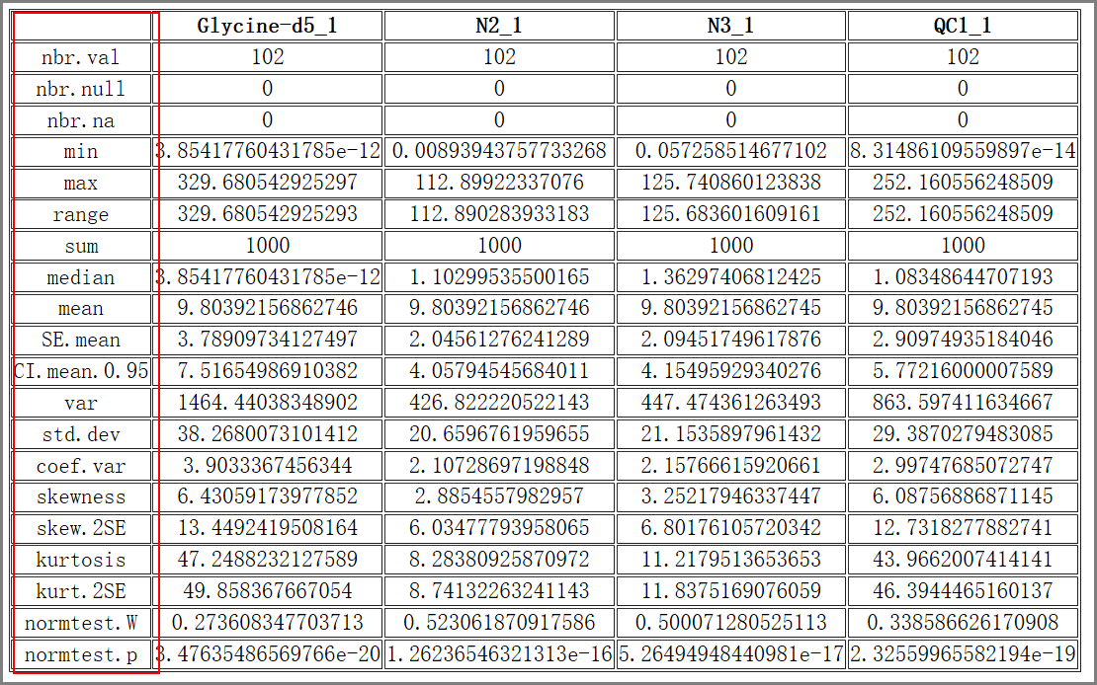

Fig.6 The basic statistics summary of four samples

#### Tool: retrieve rows from peak table

The tool takes a peak table file and a one-column compounds list file as inputs and outputs a sub-peak table file which rows correspond to the compounds list.

**Input files:**

1. Peak table file in Tab-delimited text format, with the first column as the compound identifier and others as samples.

For example:

Table.4 Peak table

|  |  |  |  |  |  |  |
| --- | --- | --- | --- | --- | --- | --- |
|  | HU_011 | HU_014 | HU_015 | HU_017 | HU_018 | HU_019 |
| (2-methoxyethoxy)propanoic acid isomer | 3.019766 | 3.814339 | 3.519691 | 2.562183 | 3.781922 | 4.161074 |
| (gamma)Glu-Leu/Ile | 3.888479 | 4.277149 | 4.195649 | 4.32376 | 4.629329 | 4.412266 |
| 1-Methyluric acid | 3.869006 | 3.837704 | 4.102254 | 4.53852 | 4.178829 | 4.516805 |
| 1-Methylxanthine | 3.717259 | 3.776851 | 4.291665 | 4.432216 | 4.11736 | 4.562052 |
| 1,3-Dimethyluric acid | 3.535461 | 3.932581 | 3.955376 | 4.228491 | 4.005545 | 4.320582 |

1. A one-column compound list file in text format.

For example:

Table.5 Compound list file

|  |
| --- |
| 1-methyluric acid |
| 1-Methylxanthine |
| 1,3-Dimethyluric acid |
| 1,7-Dimethyluric acid |

**Output files:**

A sub-peak table file in Tab-delimited text format, with the retrieved information according to the compounds list.

For example:

Table.6 Sub-peak table

|  |  |  |  |  |  |  |
| --- | --- | --- | --- | --- | --- | --- |
|  | HU_011 | HU_014 | HU_015 | HU_017 | HU_018 | HU_019 |
| 1-Methyluric acid | 3.869006 | 3.837704 | 4.102254 | 4.53852 | 4.178829 | 4.516805 |
| 1-Methylxanthine | 3.717259 | 3.776851 | 4.291665 | 4.432216 | 4.11736 | 4.562052 |
| 1,3-Dimethyluric acid | 3.535461 | 3.932581 | 3.955376 | 4.228491 | 4.005545 | 4.320582 |
| 1,7-Dimethyluric acid | 3.325199 | 4.025125 | 3.972904 | 4.109927 |  |  |

#### Tool: Row average by groups

This tool takes a peak table file and a samples-to-group design file as inputs, and outputs the averaged intensity of every compound in every group.

**Results and visualization:**

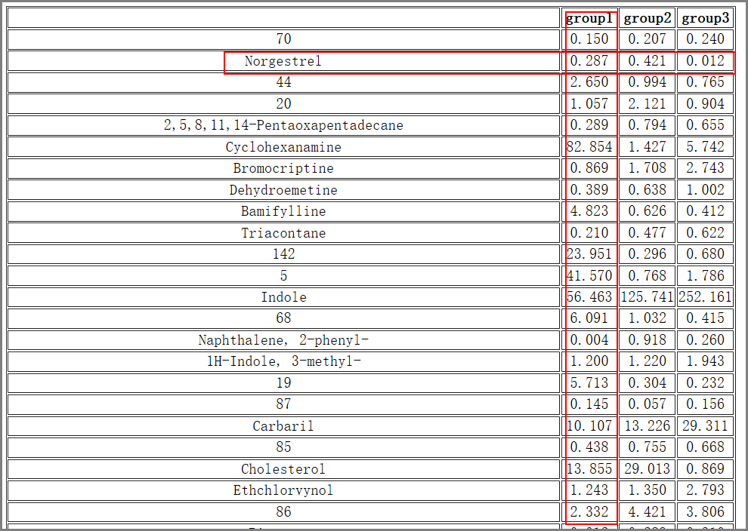Fig.7 The outputted averaged intensity of every compound in 3 groups.

### 3.3.4 Transformation

#### Tool: Log2 transformation

This tool takes a peak table file as input and performs log transformation (base 2) or median centered log2 transformation on the peaks.

**Note:**

The transformation formula is: log2 (value+1)

The median center is performed on the row (compound data).

#### Tool: Z-score transformation

This tool takes a peak table file as input and performs z-score transformation on the peaks. This method standardizes the data by mean and standard deviation of the original data. It is applicable to the cases where the maximum and minimum values are unknown, or there is outlier data beyond the range of values. Formula is new data = (original data - mean)/standard deviation.

#### Tool: Transpose

This tool takes a matrix data as input and performs transpose operation.

### 3.3.5 Merge tables

#### Tool: Merge tables by compound name

This tool takes multiple peak tables as input and merges them together. The outputted peak table will have more samples and compounds. If a compound exists in some but not all tables, it will be filled as NA in missing position in the final merged table. If same sample names exist in different tables, their common compounds will be averaged and outputted in the final table.

**Input files:**

Multiple peak table files in Tab-delimited text format, with the first column as the compound identifier and the others as samples.

For example:

Peak table 1:

Table.7 The inputted table1

|  |  |  |
| --- | --- | --- |
| AlignID | STDmix_GC_01 | STDmix_GC_02 |
| 1 | 1486892478 | 451322711 |
| Nitrogen dioxide | 5492977400 | 684433223 |
| Ethanol, 2-fluoro- | 2265686433 | 4182838129 |

Peak table2:

Table.8 The inputted table2

|  |
| --- |
|  |

|  |  |  |
| --- | --- | --- |
| AlignID | STDmix_GC_02 | STDmix_GC_03 |
| 1 | 0 | 3448620100 |
| Nitrogen dioxide | 3265968000 | 3265668000 |
| Norgestrel | 789.33 | 5315.224 |

**Output files:**

'merged_matrix.txt', merged peak table file in Tab-delimited text format.

Table.9 The merged table

|  |  |  |  |
| --- | --- | --- | --- |
| AlignID | STDmix_GC_01 | STDmix_GC_02 | STDmix_GC_03 |
| 1 | 1486892478 | 451322711 | 3448620272 |
| Nitrogen dioxide | 5492977592 | 1975200611.5 | 3265669981 |
| Ethanol, 2-fluoro- | 2265686433 | 4182838129 | NA |
| Norgestrel | NA | 789.33 | 5315.224 |

## 3.4 Statistical Analysis

### 3.4.1 Univariate statistical analysis

#### Tool: Student t test between two independent or paired groups

This tool performs the Student t-test and multiple comparison correction on the peaks of the inputted table. Group information is given by a group design file (Tab-delimited text file). The number of groups should be 2. For paired t-test, pairs are defined according to the order in each of the two groups and the number of samples must be equal in the two groups.

**Note:**

Groups number must be 2 in the sample group file.

Group names of characters or string are preferred. Numbers are also supported but not recommended.

**Input files:**

Group design file. For paired t-test, pairs are according to the order in each of the two groups.

For example:

Table.10 The group file for paired t-test, with 3 pairs (_p1, _p2, and _p3) in different color blocks

|  |  |
| --- | --- |
| HU_01_p1 | M |
| HU_02_p1 | F |
| HU_03_p2 | M |
| HU_04_p3 | M |
| HU_05_p2 | F |
| HU_06_p3 | F |

**Output files:**

1. 't_test_results.txt', t-test results with p value, log2FC, and q value.
2. 't_test_significant_results.txt', significant t-test results.

**Note:**

Groups number must be 2 in the sample group file.

Group names of characters or string are preferred. Numbers are also supported but not recommended.

**Results and visualization:**

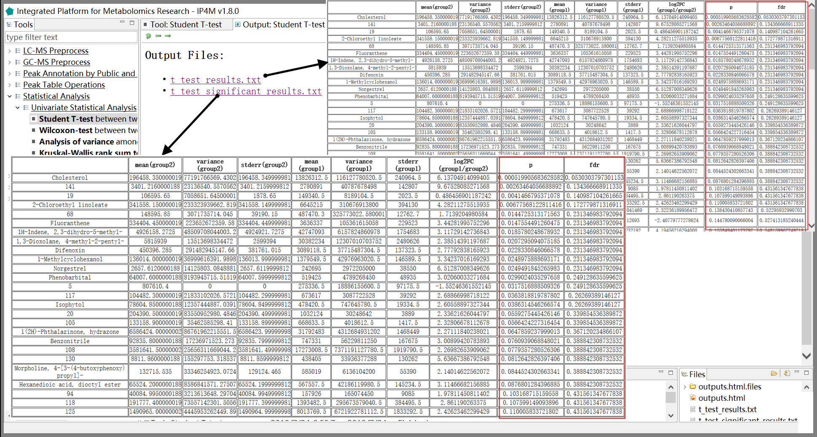

Fig.8 The outputted files with the full results and significant results of t-test method.

#### Tool: Wilcoxon-signed-rank-test between two paired groups

This tool performs the Wilcoxon-test and multiple comparison corrections to find the significant peaks on the peak table data. Group information is given by a group design file (Tab-delimited text file). The number of groups should be 2. For a paired test, pairs are according to the order in each of the two groups. For example, A-group-first-sample and B-group-first-sample are a pair. For a paired test, the number of samples must be equal in the two groups. For a paired-test, a Wilcoxon rank sum test (equivalent to the Mann-Whitney test) is carried out, otherwise, a Wilcoxon signed rank test is performed.

**Input files:**

Group design file. For a paired t-test, pairs are according to the order in each two groups.

For example:

Table.11 The group file for paired test, with 3 pairs in different color blocks

|  |  |
| --- | --- |
| HU_01_p1 | M |
| HU_02_p1 | F |
| HU_03_p2 | M |
| HU_04_p3 | M |
| HU_05_p2 | F |
| HU_06_p3 | F |

**Output files:**

1. 'wilcox_test_results.txt', Wilcoxon-test results with p value, log2FC, and q value.

2. 'wilcox _test_significant_results.txt', significant Wilcoxon-test results.

**Note:**

Group number must be 2 in the sample group file.

Group names of characters or string are preferred. Numbers are also supported but not recommended.

**Results and visualization:**

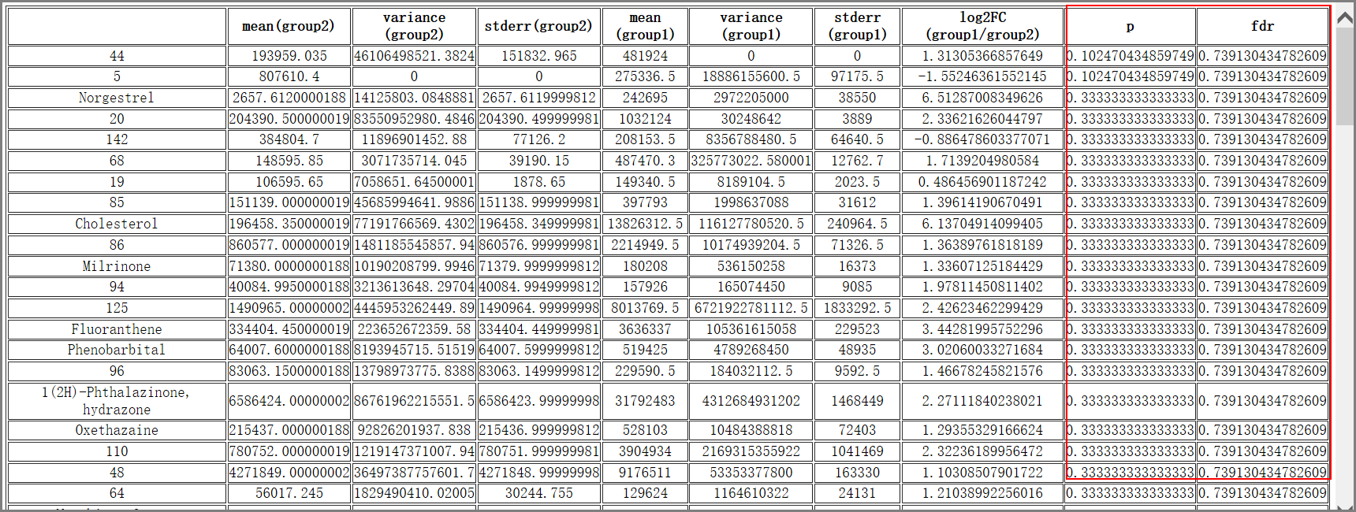

Fig.10 The results of Wilcoxon-signed-rank-test between two paired groups

#### Tool: Analysis of variance among more than two groups

This tool fits an analysis of variance model to find the significant peaks on the inputted peak table. Group information is given by a group design file (Tab-delimited text file).

**Note:**

Group names of characters or string are preferred. Numbers are also supported but not recommended.

**Results and visualization:**

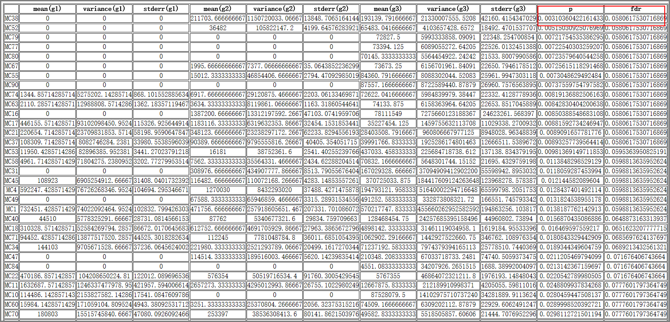

Fig.11 The result of analysis of variance among 3 groups

#### Tool: Kruskal-Wallis rank test among more than two groups

This tool performs a Kruskal-Wallis rank sum test and multiple comparison corrections to find the significant peaks on the inputted peak table. Group information is given by a group design file (Tab-delimited text file).

**Note:**

Group names of characters or string are preferred. Numbers are also supported but not recommended.

### 3.4.2 Multivariate statistical analysis

#### Tool: Principal component analysis

This tool performs a principal components analysis on the inputted peak table data. If the group design file (a Tab-delimited text file) is provided, samples in the same group will be plotted as the same color.

**Input files:**

1. Peak table file in Tab-delimited text format, with the first column as compound identifier, the others as samples.

For example:

Table.12 The inputted peak table file

|  |  |  |  |  |  |  |
| --- | --- | --- | --- | --- | --- | --- |
|  | HU_011 | HU_014 | HU_015 | HU_017 | HU_018 | HU_019 |
| (2-methoxyethoxy)propanic acid isomer | 3.019766 | 3.814339 | 3.519691 | 2.562183 | 3.781922 | 4.161074 |
| (gamma)Glu-Leu/Ile | 3.888479 | 4.277149 | 4.195649 | 4.32376 | 4.629329 | 4.412266 |
| 1-Methyluric acid | 3.869006 | 3.837704 | 4.102254 | 4.53852 | 4.178829 | 4.516805 |
| 1-Methylxanthine | 3.717259 | 3.776851 | 4.291665 | 4.432216 | 4.11736 | 4.562052 |
| 1,3-Dimethyluric acid | 3.535461 | 3.932581 | 3.955376 | 4.228491 | 4.005545 | 4.320582 |
| 1,7-Dimethyluric acid | 3.325199 | 4.025125 | 3.972904 | 4.109927 | 4.024092 | 4.326856 |
| 2-acetamido-4-methylphenyl acetate | 4.204754 | 5.181858 | 3.88568 | 4.237915 | 1.852994 | 4.080681 |
| 2-Aminoadipic acid | 4.080204 | 4.359246 | 4.249111 | 4.231404 | 4.323679 | 4.244485 |

2.(Optional), Group design file in Tab-delimited text file.

For example:

Table.13 The inputted group design file

|  |  |
| --- | --- |
| HU_011 | M |
| HU 014 | F |
| HU_015 | M |
| HU_017 | M |
| HU_018 | M |
| HU_019 | M |

**Output files:**

1. 'pca_scores.txt', PCs (scores) matrix.

2. 'pca_importance.txt', importance of PCs.

3. 'pca_rotation.txt', the matrix of variable loadings (i.e., a matrix whose columns contain the eigenvectors).

4. 'pca_plot.pdf', PCA plot using PCs score values, the default is PC1 and PC2.

**Results and visualization:**

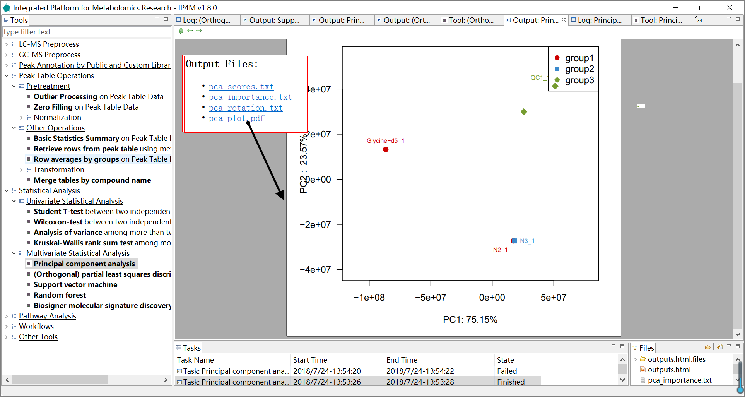

Fig.12 The resulting files and the PCA scores plot

#### Tool: (Orthogonal) partial least squares discriminant analysis

This tool performs the OPLS-DA algorithm to rank peaks on the inputted table by variable importance in projection (VIP). Group information is given by a group design file (Tab-delimited text file). OPLS-DA is only available for binary classification and the number of groups should be 2.

The orthogonal Partial Least-Squares (OPLS) algorithm was introduced by J. Trygg and Wold (2002) in order to model separately the variations of the predictors correlated and orthogonal to the response. It has a similar predictive capacity compared to PLS and improves the interpretation of the predictive components and of the systematic variation (Pinto, Trygg, and Gottfries 2012). In particular, OPLS modeling of single responses only requires one predictive component. Diagnostics such as the Q2Y metrics and permutation testing are of high importance to avoid overfitting and assess the statistical significance of the model. The VIP, which reflects both the loading weights for each component and the variability of the response explained by this component (Pinto, Trygg, and Gottfries 2012; Mehmood et al. 2012), can be used for feature ranking and selection (J. Trygg and Wold 2002; Pinto, Trygg, and Gottfries 2012).

**Input files:**

1. Peak table file in Tab-delimited text format, with the first column as the compound identifier and others as samples.

For example:

Table.13 The inputted peak table file

|  |  |  |  |  |  |  |
| --- | --- | --- | --- | --- | --- | --- |
|  | HU_011 | HU_014 | HU_015 | HU_017 | HU_018 | HU_019 |
| (2-methoxyethoxy)propanoic acid isomer | 3.019766 | 3.814339 | 3.519691 | 2.562183 | 3.781922 | 4.161074 |
| (gamma)Glu-Leu/Ile | 3.888479 | 4.277149 | 4.195649 | 4.32376 | 4.629329 | 4.412266 |
| 1-Methyluric acid | 3.869006 | 3.837704 | 4.102254 | 4.53852 | 4.178829 | 4.516805 |
| 1-Methylxanthine | 3.717259 | 3.776851 | 4.291665 | 4.432216 | 4.11736 | 4.562052 |
| 1,3-Dimethyluric acid | 3.535461 | 3.932581 | 3.955376 | 4.228491 | 4.005545 | 4.320582 |
| 1,7-Dimethyluric acid | 3.325199 | 4.025125 | 3.972904 | 4.109927 | 4.024092 | 4.326856 |
| 2-acetamido-4-methylphenyl acetate | 4.204754 | 5.181858 | 3.88568 | 4.237915 | 1.852994 | 4.080681 |
| 2-Aminoadipic acid | 4.080204 | 4.359246 | 4.249111 | 4.231404 | 4.323679 | 4.244485 |

1. Group design file in Tab-delimited text file with two columns (samplename groupname).

For example:

Table.14 The inputted group design file

|  |  |
| --- | --- |
| HU_011 | M |
| HU 014 | F |
| HU_015 | M |
| HU_017 | M |
| HU_018 | M |
| HU_019 | M |

**Output files:**

1. 'oplsda_variable_results.txt', feature ranked results that are sorted by VIP.

2. 'oplsda_variable_significant_results.txt', significant feature results.

3. 'oplsda_samples_results.txt', OPLS-DA model sample prediction results using inputted data.

4. 'oplsda_prediction_summary.txt', prediction summary.

5. 'oplsda_figure.pdf', OPLS-DA plot.

**Parameter:**

1. VIP-value: A numerical variable indicating the Variable Importance in Projection.

2. orthogonal components: The number of orthogonal components (for OPLS only); when set to 0 [default], PLS will be performed; otherwise OPLS will be performed; when set to NA, OPLS is performed and the number of orthogonal components is automatically computed by using the cross-validation (with a maximum of 9 orthogonal components).

3. scaling methods: Either no centering nor scaling (’none’), mean-centering only (’center’), mean-centering and Pareto scaling (’Pareto’), or mean-centering and unit variance scaling (’standard’) [default].

Mean-centering: 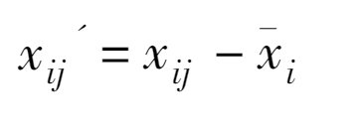

Pareto scaling: 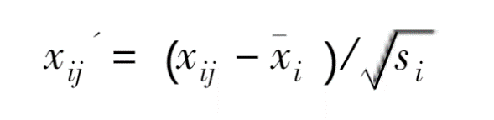

unit variance scaling: 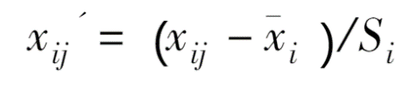

Comments: 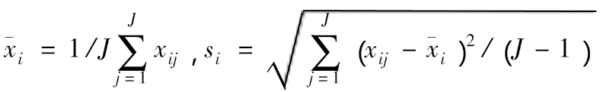

4. crossvalI: Number of cross-validation segments (default is 7); The number of samples (rows of ’x’) must be at least >= crossvalI

5. permutation: Number of random permutations of response labels to estimate R2Y and Q2Y significance by permutation testing [default is 20 for single response models (without train/test partition), and 0 otherwise]

6. graphical parameters: This tool provides ten graphic parameters for ten different graphic types. They are displayed in 'oplsda_figure.pdf' file.

**Note：**

Group number must be 2 in the sample group file.

Group names of characters or string are preferred. Numbers are also supported but not recommended.

**Reference:**

[1] Thevenot, E.A., Roux, A., Xu, Y., Ezan, E., Junot, C. 2015. Analysis of the human adult urinary metabolome variations with age, body mass index and gender by implementing a comprehensive workflow for univariate and OPLS statistical analyses. Journal of Proteome Research. 14: 3322-3335.

[2] Trygg J, Wold S. Orthogonal projections to latent structures (O-PLS) [J]. Journal of Chemometrics 2002,16:119 –128.

[3] Rui C P, Trygg J, Gottfries J. Advantages of orthogonal inspection in chemometrics[J]. Journal of Chemometrics, 2012, 26(6):231–235.

[4] Mehmood, T., KH. Liland, L. Snipen, and S. Saebo. 2012. “A Review of Variable Selection Methods in Partial Least Squares Regression.” Chemometrics and Intelligent Laboratory Systems 118 (0): 62–69.

[5] Galindo-Prieto B., Eriksson L. and Trygg J. (2014). Variable influence on projection (VIP) for orthogonal projections to latent structures (OPLS). Journal of Chemometrics 28, 623-632.

**Results and visualization:**

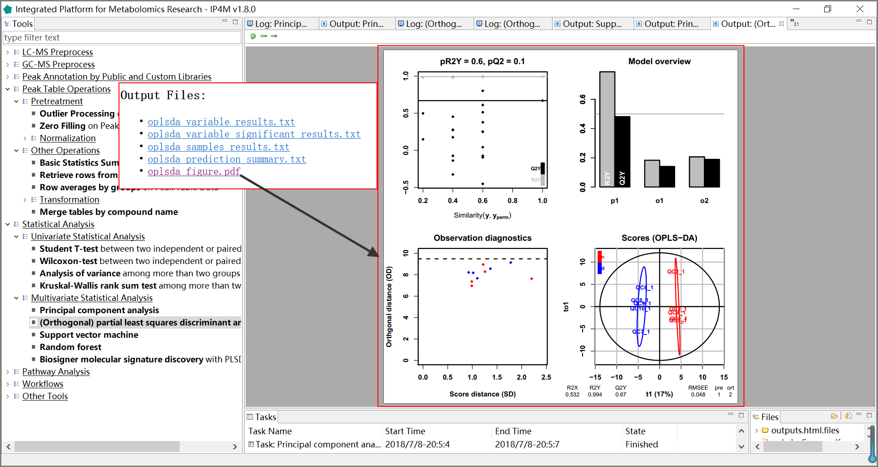

Fig.13 The resulting files and the summary plot of OPLS-DA

#### Tool: Support vector machine

This tool performs support vector machines to rank peaks in the inputted table by SVM-RFE. Group information is given by a group design file (Tab-delimited text file).

The SVM-RFE algorithm proposed by Guyon returns a ranking of the features of a classification problem by training an SVM with a linear kernel and removing the feature with the smallest ranking criterion. This criterion is the w value of the decision hyperplane given by the SVM. For more detailed information, please review the original paper.

**Input files:**

1. Peak table file in Tab-delimited text format, with the first column as the compound identifier and the others as samples.

For example:

Table.15 The inputted peak table file

|  |  |  |  |  |  |  |
| --- | --- | --- | --- | --- | --- | --- |
|  | HU_011 | HU_014 | HU_015 | HU_017 | HU_018 | HU_019 |
| (2-methoxyethoxy)propanoic acid isomer | 3.019766 | 3.814339 | 3.519691 | 2.562183 | 3.781922 | 4.161074 |
| (gamma)Glu-Leu/Ile | 3.888479 | 4.277149 | 4.195649 | 4.32376 | 4.629329 | 4.412266 |
| 1-Methyluric acid | 3.869006 | 3.837704 | 4.102254 | 4.53852 | 4.178829 | 4.516805 |
| 1-Methylxanthine | 3.717259 | 3.776851 | 4.291665 | 4.432216 | 4.11736 | 4.562052 |
| 1,3-Dimethyluric acid | 3.535461 | 3.932581 | 3.955376 | 4.228491 | 4.005545 | 4.320582 |
| 1,7-Dimethyluric acid | 3.325199 | 4.025125 | 3.972904 | 4.109927 | 4.024092 | 4.326856 |
| 2-acetamido-4-methylphenyl acetate | 4.204754 | 5.181858 | 3.88568 | 4.237915 | 1.852994 | 4.080681 |
| 2-Aminoadipic acid | 4.080204 | 4.359246 | 4.249111 | 4.231404 | 4.323679 | 4.244485 |

1. Group design file in Tab-delimited text file with two columns (samplename groupname).

For example:

Table.16 The inputted group design file

|  |  |
| --- | --- |
| HU_011 | M |
| HU 014 | F |
| HU_015 | M |
| HU_017 | M |
| HU_018 | M |
| HU_019 | M |

**Output files:**

1. 'svm_summary.txt', summary information about SVM.

2. 'svm_variable_results.txt', feature ranked results that are sorted by SVM-RFE.

3. ' svm_samples_results.txt', SVM model sample prediction results using inputted data.

4. 'svm_prediction_summary.txt', prediction summary.

5. 'support_vectors.txt', support vectors in the model.

6. 'svm_plot.pdf', SVM plot.

**Parameter:**

kernel function: The kernel function reflects the similarity between the inputted data. The correct choice of kernel parameters is crucial for obtaining good results, which practically means that an extensive search must be conducted on the parameter space before results can be trusted.

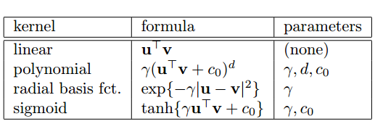

1. Linear kernel: Simple and safe, try it first. The model is interpretative. It indicates which features or data points in the model are important. But it is not available if the data is not linearly separable.
2. Polynomial kernel: Less restrictive than linear applications, it can solve non-linear separable data. But it is more complicated with three parameters.
3. Radial basis function (RBF): Usually defined as a monotonic function of the Euclidean distance between any points in space to a certain center. It maps primitive features to infinite dimensions. It is able to achieve nonlinear mapping and also has less numerical difficulties.
4. Sigmoid: Squashes numbers to the range [0, 1]. Historically popular since they have a nice interpretation as a saturating “firing rate” of a neuron. But there are some fatal disadvantages. For instance, saturated neurons “kill” the gradients, sigmoid outputs are not zero-centered, and exp () is a bit computationally expensive.

**Note:**

Group names of characters or string are preferred. Numbers are also supported but not recommended.

**Reference:**

[1] Marchiori E, Sebag M. Bayesian Learning with Local Support Vector Machines for Cancer Classification with Gene Expression Data[M]// Applications of Evolutionary Computing. Springer Berlin Heidelberg, 2005:74-83.[2] Gene Selection for Cancer Classification using Support Vector Machines (2002) Isabelle Guyon, Jason Weston, Stephen Barnhill, Vladimir Vapnik.

**Results and visualization:**

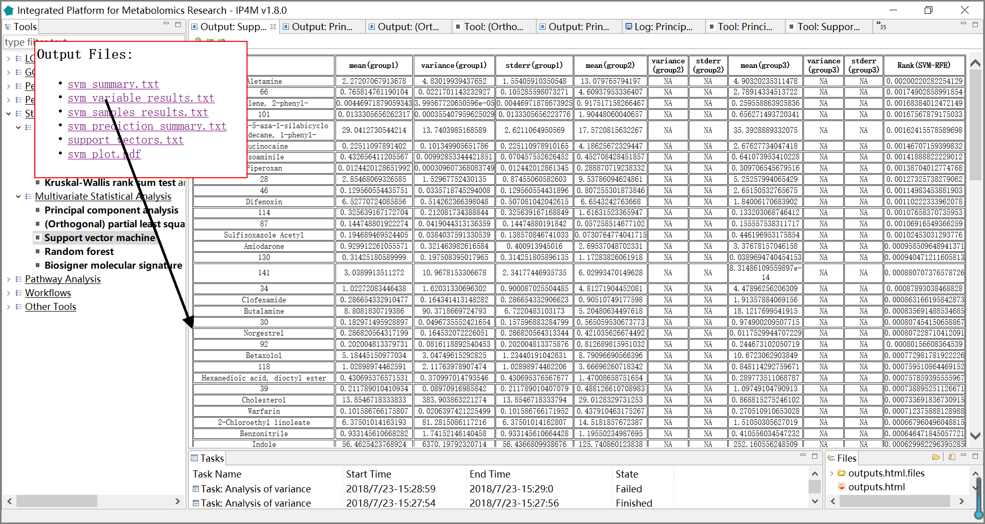

Fig.14 The resulting files and the variable ranks of SVM (3 groups)

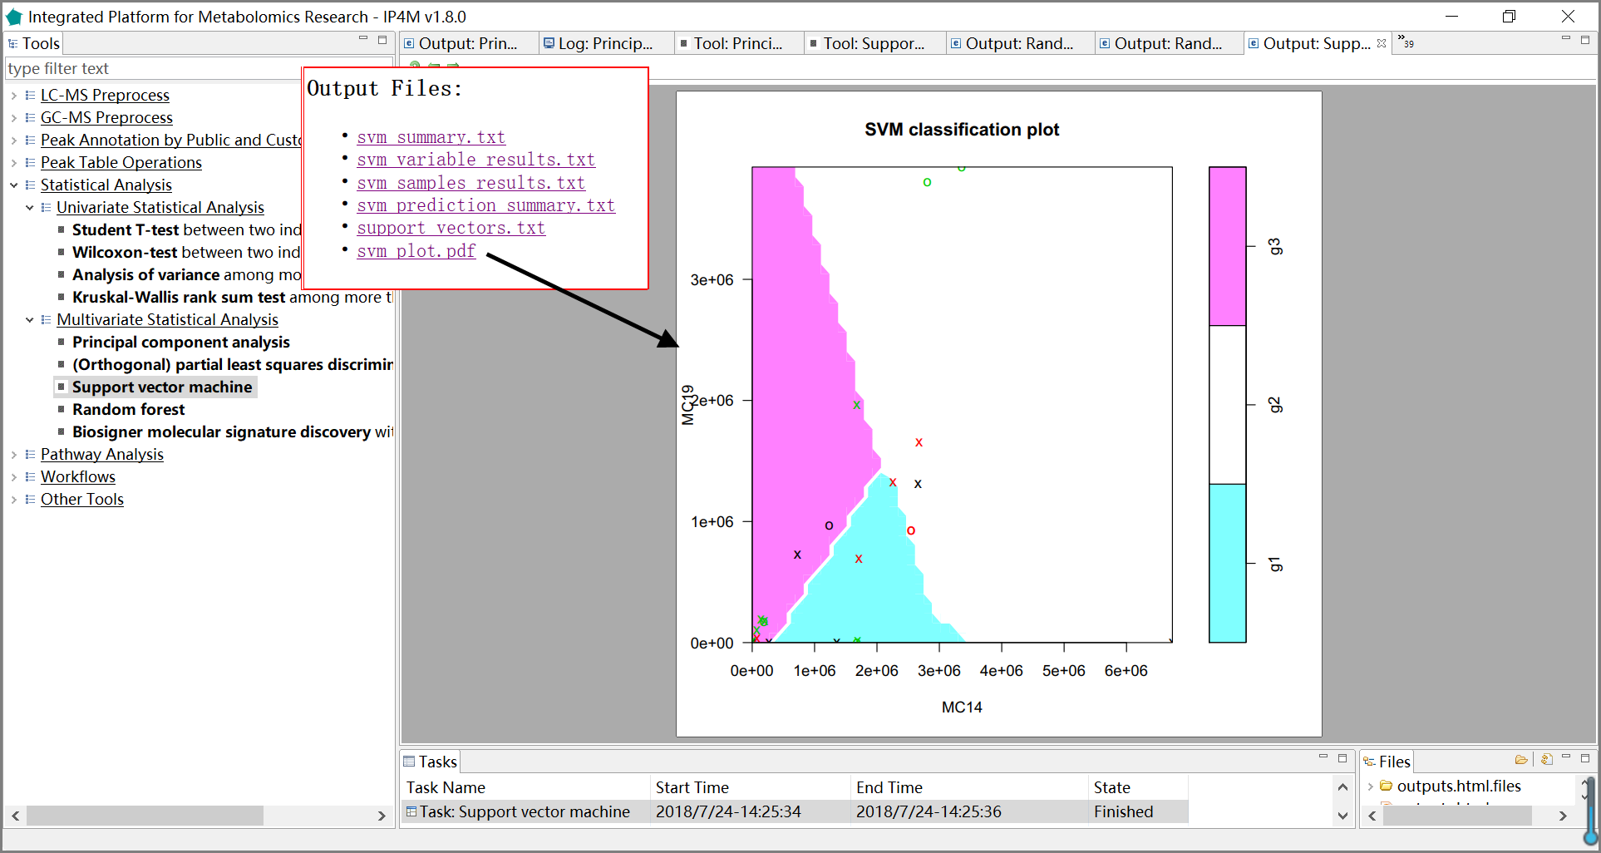

Fig.15 The resulting files and the classification plot of SVM (3 groups)

#### Tool: Random forest

This tool implements Breiman's random forest algorithm (R randomforest package) for classification and peak ranking based on the inputted table. The peaks are ranked by the mean decrease in Gini index. Group information is given by a group design file (Tab-delimited text file).

**Input files:**

1. Peak table file in Tab-delimited text format, with the first column as the compound identifier and the others as samples.

For example:

Table.17 The inputted peak table file

|  |  |  |  |  |  |  |
| --- | --- | --- | --- | --- | --- | --- |
|  | HU_011 | HU_014 | HU_015 | HU_017 | HU_018 | HU_019 |
| (2-methoxyethoxy)propanoic acid isomer | 3.019766 | 3.814339 | 3.519691 | 2.562183 | 3.781922 | 4.161074 |
| (gamma)Glu-Leu/Ile | 3.888479 | 4.277149 | 4.195649 | 4.32376 | 4.629329 | 4.412266 |
| 1-Methyluric acid | 3.869006 | 3.837704 | 4.102254 | 4.53852 | 4.178829 | 4.516805 |
| 1-Methylxanthine | 3.717259 | 3.776851 | 4.291665 | 4.432216 | 4.11736 | 4.562052 |
| 1,3-Dimethyluric acid | 3.535461 | 3.932581 | 3.955376 | 4.228491 | 4.005545 | 4.320582 |
| 1,7-Dimethyluric acid | 3.325199 | 4.025125 | 3.972904 | 4.109927 | 4.024092 | 4.326856 |
| 2-acetamido-4-methylphenyl acetate | 4.204754 | 5.181858 | 3.88568 | 4.237915 | 1.852994 | 4.080681 |
| 2-Aminoadipic acid | 4.080204 | 4.359246 | 4.249111 | 4.231404 | 4.323679 | 4.244485 |

2. Group design file in Tab-delimited text format with two columns (samplename groupname).

For example:

Table.18 The inputted group design file

|  |  |
| --- | --- |
| HU_011 | M |
| HU 014 | F |
| HU_015 | M |
| HU_017 | M |
| HU_018 | M |
| HU_019 | M |

**Output files:**

1. 'rf_summary.txt ', summary information about random forest model.

2. 'rf_variable_results.txt ', feature rank results that sorted by mean decrease in Gini index.

3. 'rf_prediction_summary.txt ', random forest model sample prediction results using inputted data.

4. 'rf_prediction_summary.txt', prediction summary.

5. 'rf_error_rates_plot.pdf ', error rates plot in the model.

6. 'rf_predictions_margin_plot.pdf ', predictions_margin plot.

**Parameter:**

1. number of trees: It specifies the number of decision trees included in the random forest. The default is 500.

2. mtry: Mtry specifies the number of variables used in the node for the binary tree. The default is the quadratic root of the data set variable (classification model) or one- third (predictive model). Generally, it is necessary to carry out artificial selection step by step to determine the optimal m value.

3. replacement: Specify the way to randomly sample Bootstrap. The default is resampling.

4. nodesize: The minimum number of decision tree nodes. By default, the discriminant model is 1 and the regression model is 5.

5. maxnodes: The maximum number of decision tree nodes

**Results and visualization:**

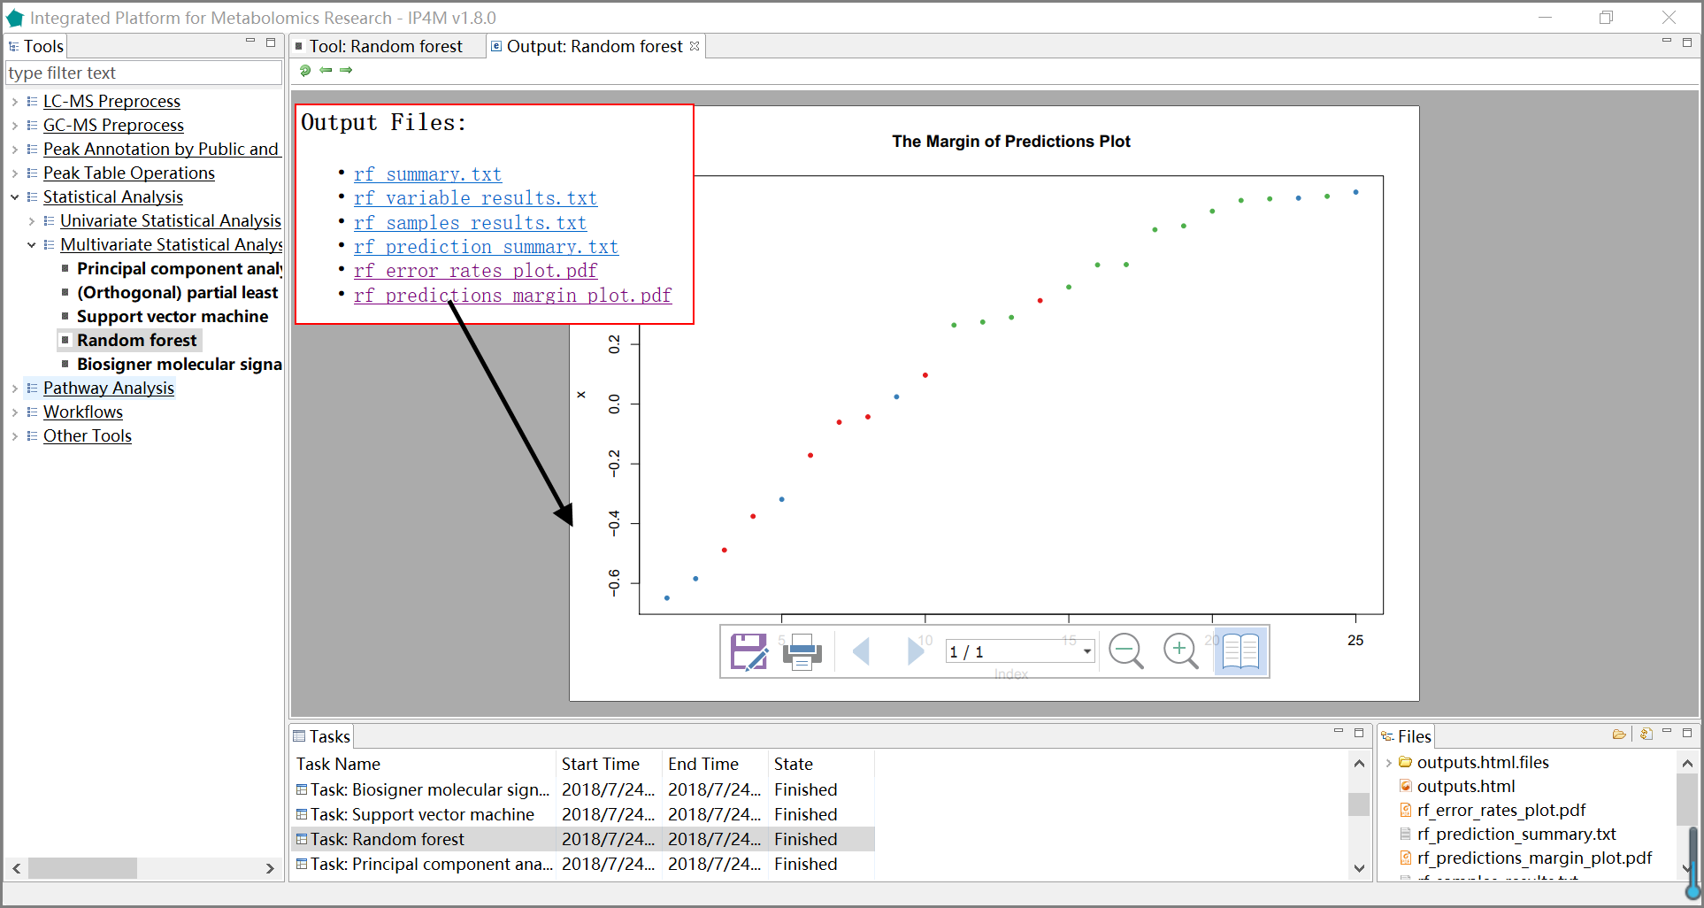

Fig.16 The resulting files and the margin of prediction plot of RF

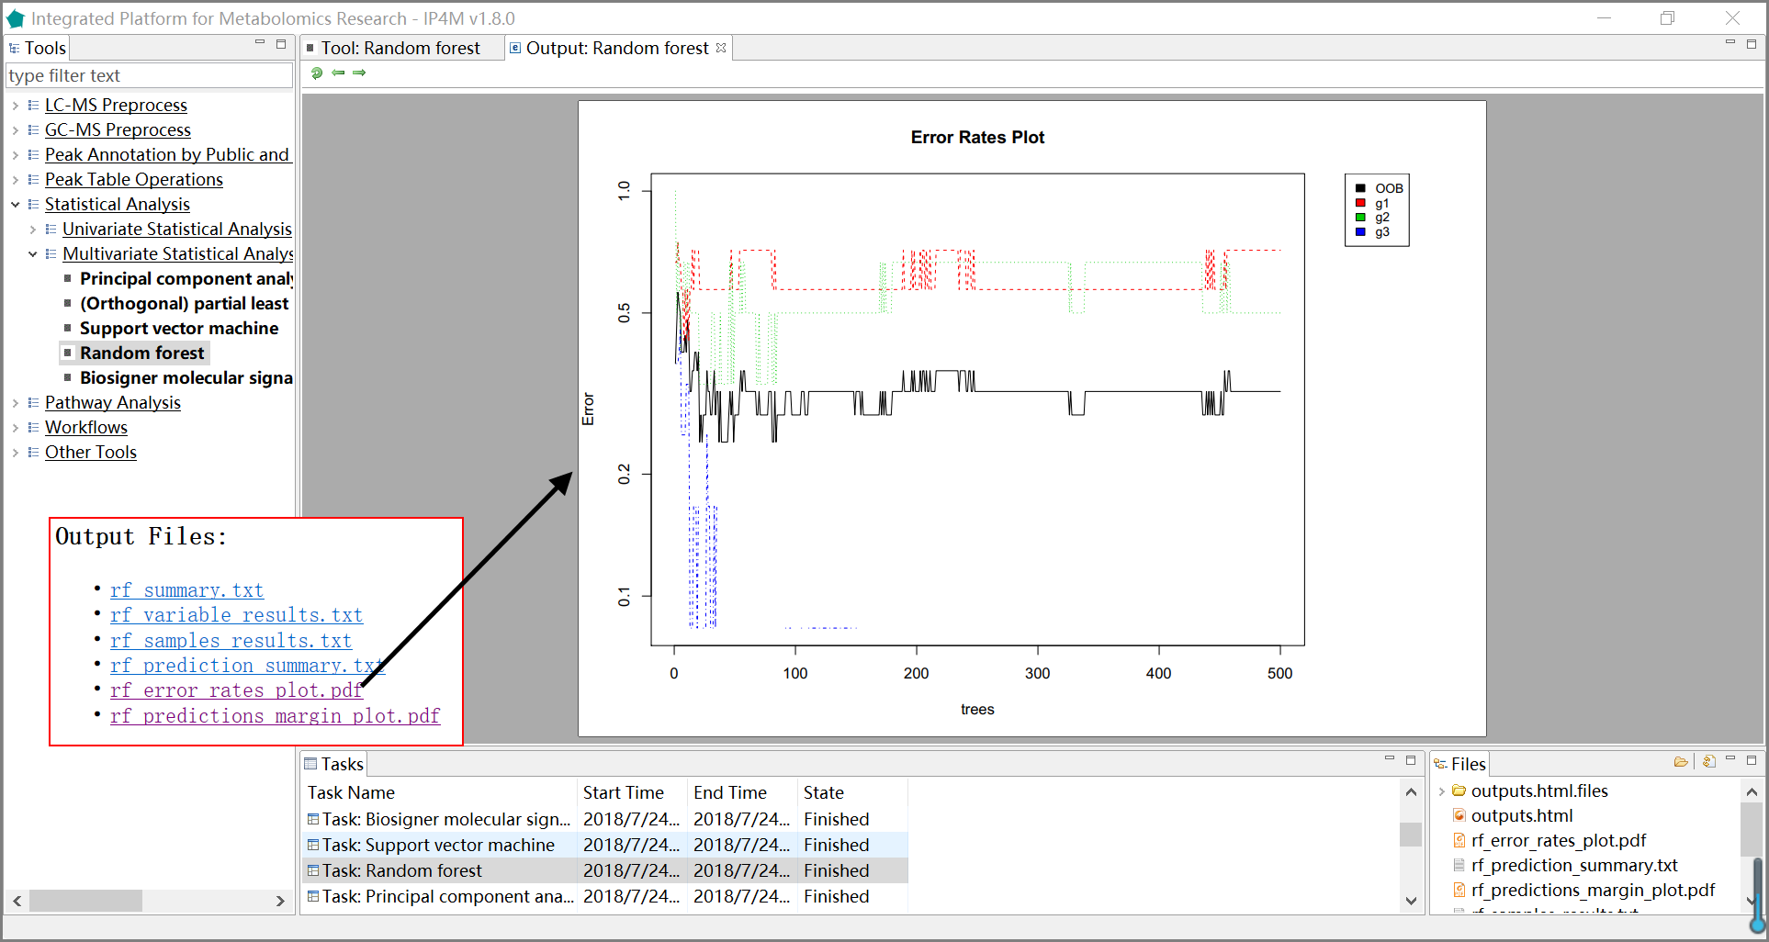

Fig.17 The resulting files and error rate plot of RF

#### Tool: Biosigner molecular signature discovery with PLSDA, RF, and SVM

This tool is the wrapper of the R package 'biosigner' and aims to find the significant peaks in the inputted table. Three binary classifiers have been jointly used in biosigner, namely Partial Least Square Discriminant Analysis (PLS-DA), Random Forest (RF) and Support Vector Machines (SVM), to achieve high levels of prediction accuracy. Group information is given by a group design file (Tab-delimited text file).

**Input files:**

1. Peak table file in Tab-delimited text format, with the first column as the compound identifier and the others as samples.

For example:

Table.19 The inputted peak table file

|  |  |  |  |  |  |  |
| --- | --- | --- | --- | --- | --- | --- |
|  | HU_011 | HU_014 | HU_015 | HU_017 | HU_018 | HU_019 |
| (2-methoxyethoxy)propanoic acid isomer | 3.019766 | 3.814339 | 3.519691 | 2.562183 | 3.781922 | 4.161074 |
| (gamma)Glu-Leu/Ile | 3.888479 | 4.277149 | 4.195649 | 4.32376 | 4.629329 | 4.412266 |
| 1-Methyluric acid | 3.869006 | 3.837704 | 4.102254 | 4.53852 | 4.178829 | 4.516805 |
| 1-Methylxanthine | 3.717259 | 3.776851 | 4.291665 | 4.432216 | 4.11736 | 4.562052 |
| 1,3-Dimethyluric acid | 3.535461 | 3.932581 | 3.955376 | 4.228491 | 4.005545 | 4.320582 |
| 1,7-Dimethyluric acid | 3.325199 | 4.025125 | 3.972904 | 4.109927 | 4.024092 | 4.326856 |
| 2-acetamido-4-methylphenyl acetate | 4.204754 | 5.181858 | 3.88568 | 4.237915 | 1.852994 | 4.080681 |
| 2-Aminoadipic acid | 4.080204 | 4.359246 | 4.249111 | 4.231404 | 4.323679 | 4.244485 |

2. Group design file in Tab-delimited text format with two columns (samplename groupname).

For example:

Table.20 The inputted group design file

|  |  |
| --- | --- |
| HU_011 | M |
| HU 014 | F |
| HU_015 | M |
| HU_017 | M |
| HU_018 | M |
| HU_019 | M |

**Output files:**

1. 'biosigner_summary.txt', summary information about biosigner algorithm.

2. 'biosigner_variable_results.txt', ranked feature results by biosigner algorithm.

3. 'biosigner_variable_significant_results.txt', significant feature results.

4. ' biosigner_figure-tier.pdf ', displays classifier tiers from selected features.

5. ' biosigner_figure-boxplot.pdf ', individual boxplots from selected features.

**Parameter:**

1. bootstraps for resampling: The number of bootstraps is set to 5 to speed up computations when generating this vignette; we however recommend to keep the default 50 value for analyzing (otherwise signatures may be less stable).

2. pvalN: To speed up the selection, only variables which significantly improve the model up to two times this threshold (to take into account potential fluctuations) are computed.

1. Selection tiers: Tiers from S, A, up to E by decreasing relevance. The (S) tier corresponds to the final signature, i.e. features which passed through all the backward selection steps. In contrast, features from the other tiers were discarded during the last (A) or previous (B to E) selection rounds. Note that tierMaxC = ‘A’ argument in the print and plot methods can be used to view the features from the larger S+A signatures (especially when no S features have been found, or when the performance of the S model is much lower than the S+A model).

**Note:**

1. Group number must be 2 in the sample group file.

2. Group names of characters or string are preferred. Numbers are also supported but not recommended.

3. The algorithm returns the tier of each feature for the selected classifier (s): tier S corresponds to the final signature, i.e., features which have been found significant in all the selection steps; features with tier A have been found significant in all but the last selection, and so on for tier B to D. Tier E regroup all previous round of selection.

**Reference:**

[1] Rinaudo P, Boudah S, Junot C, et al. biosigner: A New Method for the Discovery of Significant Molecular Signatures from Omics Data[J]. Frontiers in Molecular Biosciences, 2016, 3.

**Results and visualization:**

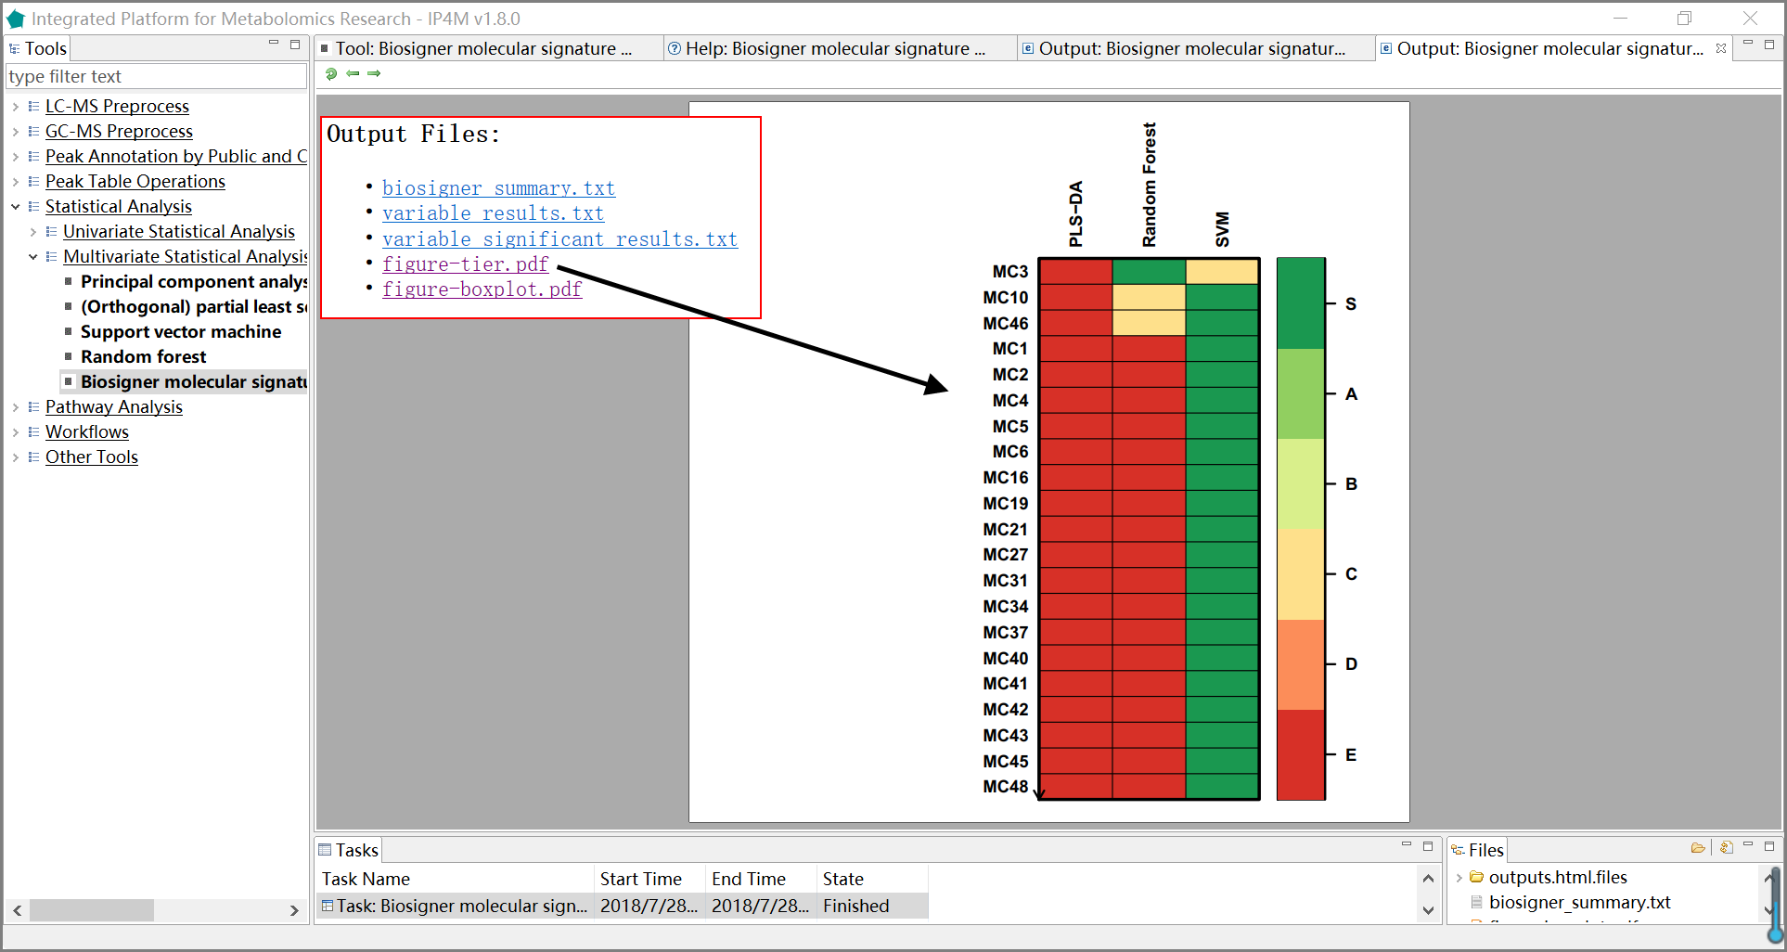

Fig.18 The resulting files and the potential biomarker (signatures) plot of biosigner

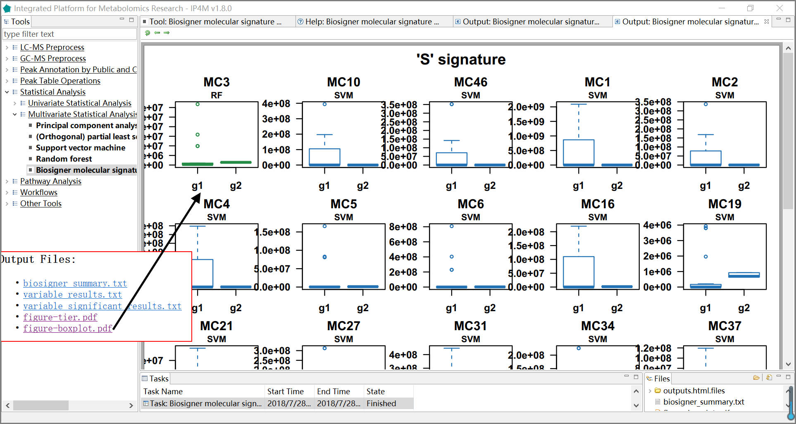

Fig.19 The resulting files and the boxplot of ‘S’ signatures by biosigner.

## 3.5 Pathway Analysis

### Tool: Compounds ID mapping

The tool takes a one-column compound list file as input and performs libraries (HMDB, PubChem, KEGG, etc.) IDs and basic information searching. This is a wrapper of the popular R package metaboAnalystR (https://github.com/xialab/MetaboAnalystR).

**Results and visualization:**

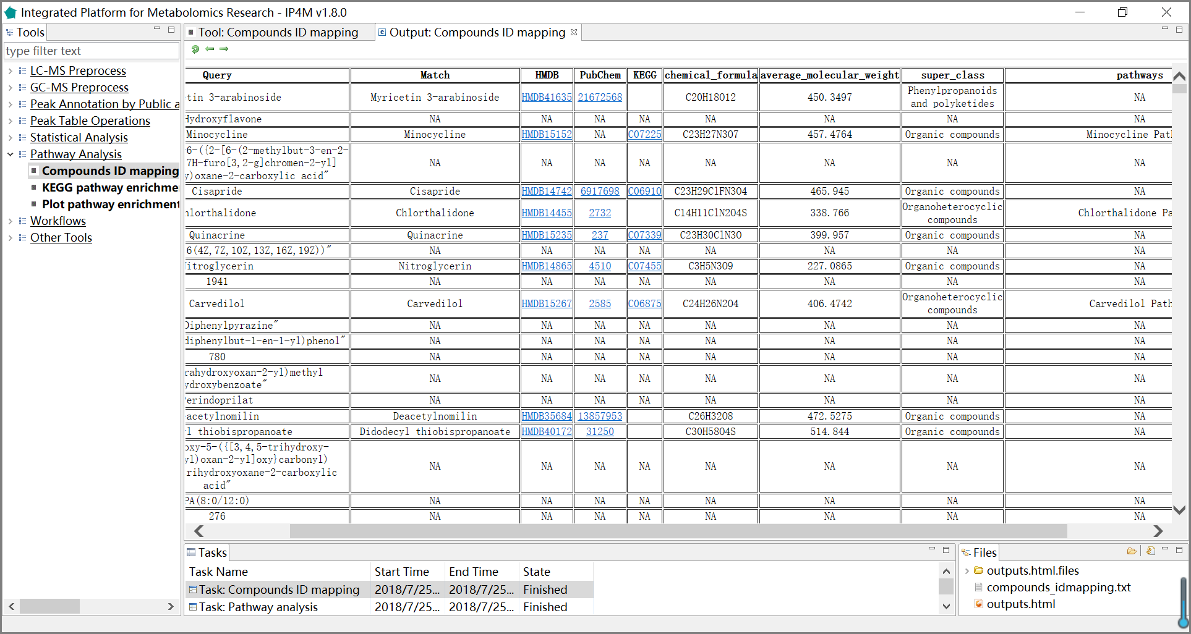

Fig.20 The resulting file of compound IDs annotation.

### Tool: Pathway analysis on compounds ID mapping results

KEGG (Kyoto Encyclopedia of Genes and Genomes) is a database resource that integrates genomic, chemical and systemic functional information. Gene catalogs from completely sequenced genomes are linked to higher-level systemic functions of the cell, the organism, and the ecosystem. This tool is a wrapper of the ‘metabolic pathway analysis’ modules of the popular MetaboAnalyst platform.

The tool takes a compounds annotation file as input and performs pathway analysis based on information from KEGG.

**Parameter:**

1. pathway library: 21 different species libraries have been provided, including Human, Mouse, Rat, Cow, Chicken, Zebrafish, Arabidopsis thaliana, Rice, Drosophila, Malaria, Budding yeast, E.coli., etc., with a total of 1600 pathways.

2. representation analysis algorithm:

hypergeometric test: In statistics, the hypergeometric test uses the hypergeometric distribution to calculate the statistical significance of having drawn a specific {\displaystyle k} k successes (out of {\displaystyle n} n total draws) from the aforementioned population. The test is often used to identify which subpopulations are over- or under-represented in a sample.

Fisher's exact test: It is a statistical significance test used in the analysis of contingency tables. The test is useful for categorical data that result from classifying objects in two different ways; it is used to examine the significance of the association (contingency) between the two kinds of classification.

3. Specify pathway topology analysis algorithm:

The module provides two popular topological measures found on the left-panel to provide users greater insight into their networks.

Out-degree centrality: It refers to the number of links a node has to other nodes.

Relative betweenness centrality: It represents the degree of centrality a node has in a network by measuring the number of shortest paths that pass through that node.

Nodes with high scores in both measures are more likely to be important hubs.

**Reference:**

[1] Xia J, Wishart D S. Web-based inference of biological patterns, functions and pathways from metabolomic data using MetaboAnalyst[J]. Nature Protocols, 2011, 6(6):743-760.

[2] Chong, J., et al. (2018) MetaboAnalyst 4.0: towards more transparent and integrative metabolomics analysis. Nucleic acids research, 46, W486-w494.

<http://www.metaboanalyst.ca>.

**Results and visualization:**

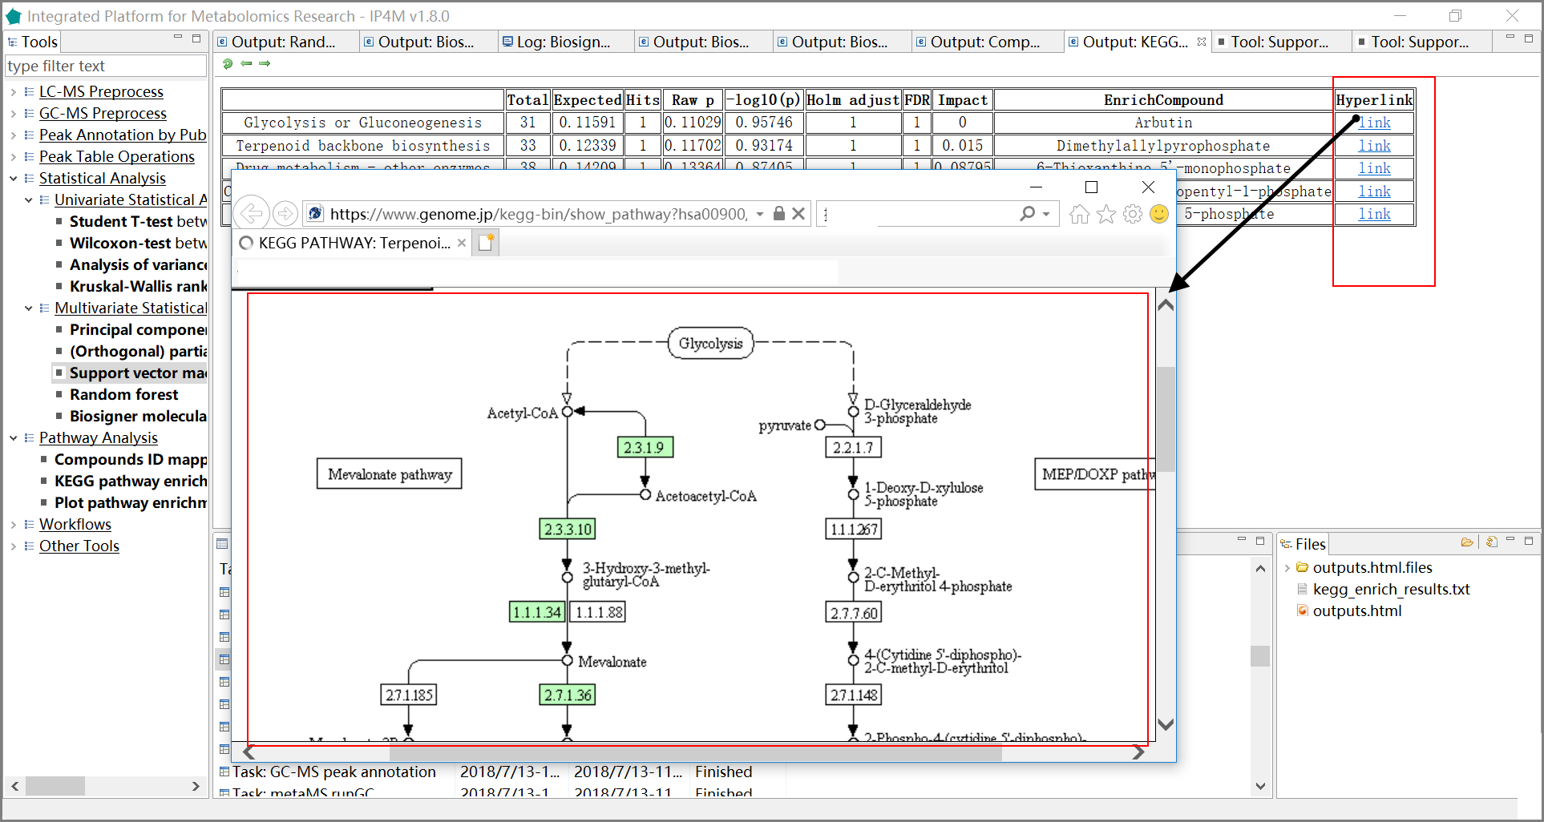

Fig.21 The results of pathway analysis with detailed information and hyperlink of the pathways.

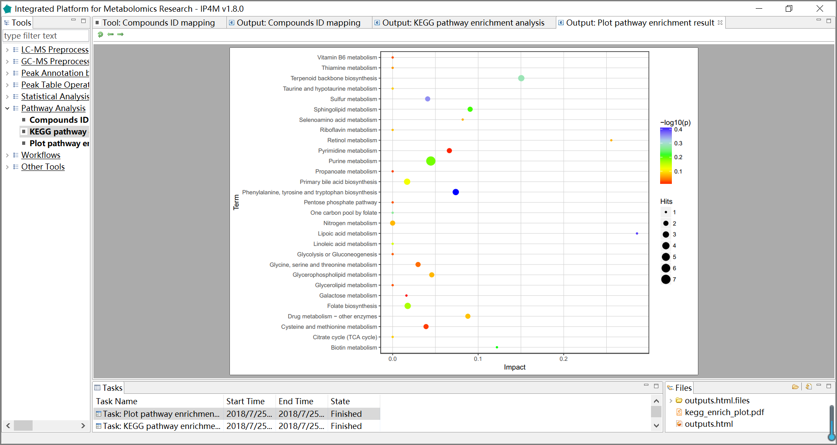

Fig.22 The pathway analysis plot of the first 30 compounds

### Tool: Enrichment analysis on compounds ID mapping results

The tool takes a one-column compound list file and performs metabolite set enrichment analysis for human and mammalian species. The analysis is based on eight metabolite set libraries containing ~7000 groups of biologically meaningful metabolite sets collected primarily from human studies. This tool is a wrapper of the ‘enrichment analysis’ modules of the popular MetaboAnalyst platform.

**Parameter:**

metabolite set library: Eight different metabolite set libraries have been provided, containing ~6300 groups of biologically meaningful metabolite sets collected primarily from human studies. Pathway-associated metabolite set library contains 99 metabolite sets based on normal metabolic pathways. Diseased-associated metabolite set library contains 344 metabolite sets reported in human blood. Disease-associated metabolite set library contains 384 metabolite sets reported in human urine. Disease-associated metabolite set (CSF) library contains 166 metabolite sets reported in human cerebral spinal fluid (CSF). SNP-associated metabolite set library contains 4598 metabolite sets based on their associations with detected single nucleotide polymorphisms (SNPs) loci. Predicted metabolite set library contains 912 metabolic sets that are predicted to be changed in the case of dysfunctional enzymes using genome-scale network model of human metabolism. Location-based metabolite set library contains 73 metabolite sets based on organ, tissue and subcellular localizations. Drug-pathway-associated metabolite set library contains 461 metabolite sets based on drug pathway.

**Reference:**

[1] Xia J, Wishart D S. Web-based inference of biological patterns, functions and pathways from metabolomic data using MetaboAnalyst[J]. Nature Protocols, 2011, 6(6):743-760.

[2] Chong, J., et al. (2018) MetaboAnalyst 4.0: towards more transparent and integrative metabolomics analysis. Nucleic acids research, 46, W486-w494.

<http://www.metaboanalyst.ca>.

## 3.6 Workflows

### 3.6.1 GC-MS data preprocessing workflow: from raw data to peak table

This workflow takes multiple GC-MS raw data files in netCDF or mzXML format as inputs and outputs a peak table. It performs GC-MS data preprocessing and peak table operation, including mainly peak detection, spectrum aligning, metabolites annotation and peak table pretreatment.

**Input files:**

Multiple GC-MS raw data files in netCDF or mzXML format.

**Output files:**

'gcms_raw_pkTable.txt', raw peak table is generated with one line per "compound" and one column per sample.

'gcms_mass_spectra.msp', Corresponding pseudospectrum(compound) mass spectrum information in MSP format, the identifier is same in peak table file.

'gcms_mass_spectra_999norm.msp', intensities normalized mass spectrum information in MSP format, intensities sum=999.

'identified_pkTable.txt', identified peak table file in Tab-delimited text format.

'identified_uniq_pkTable.txt', identified unique peak table file in Tab-delimited text format. When row names are duplication, the row with the maximum intensity will be retained.

'detailed_information.txt', detailed information about query and database relationship in library searching.

'zero_filled_pkTable.txt', zero filled peak table file in Tab-delimited text format.

'total_area_norm_pkTable.txt', total area normalized peak table file in Tab-delimited text format.

'log2_transformed_pkTable.txt', log2 transformed peak table file in Tab-delimited text format.

**Results and visualization:**

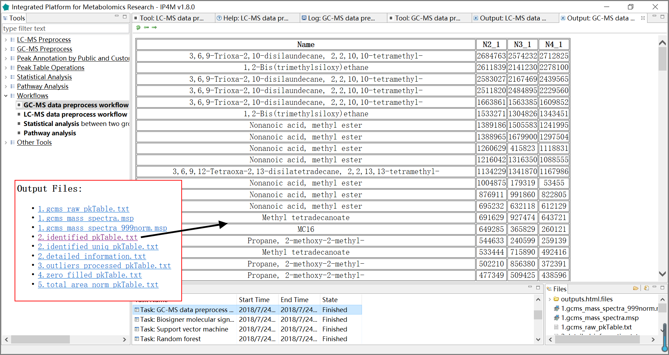

Fig.23 The outputted files and the identified peak table of GC-MS data processing workflow

### 3.6.2 LC-MS data preprocessing workflow: from raw data to peak table

This workflow takes multiple LC-MS raw data files in netCDF or mzXML format as inputs and outputs peak table. It performs LC-MS data preprocessing and peak table operation, including peak detection, spectrum aligning, metabolites annotation and peak table pretreatment.

**Input files:**

Multiple GC-MS raw data files in netCDF or mzXML format.

**Output files:**

'lcms_raw_pkTable.txt', a peak table is generated with one line per "compound" and one column per sample.

'identified_pkTable.txt', identified peak table file in Tab-delimited text format.

'identified_uniq_pkTable.txt', identified unique peak table file in Tab-delimited text format. When row names are duplication, the row with the maximum intensity will be retained.

'detailed_information.txt', detailed information about query and database relationship in library searching.

'zero_filled_pkTable.txt', zero filled peak table file in Tab-delimited text format.

'total_area_norm_pkTable.txt', total area normalized peak table file in Tab-delimited text format.

'log2_transformed_pkTable.txt', log2 transformed peak table file in Tab-delimited text format.

**Results and visualization:**

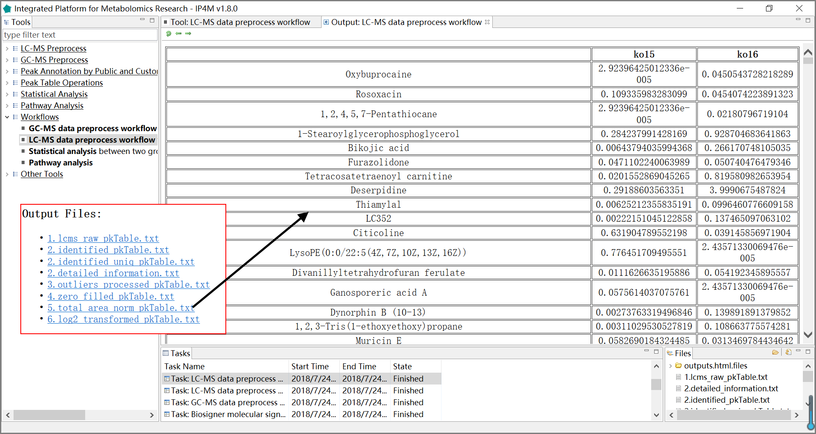 Fig.24 The outputted files and the total area normalized peak table of LC-MS data processing workflow

### 3.6.3 Statistical analysis based on peak table

This workflow takes a peak table file and a group design file as inputs. It performs all univariate and multivariate statistical analysis as user selected (between two groups).

**Input files:**

1. Peak table file in Tab-delimited text format, with the first column as the compound identifier and the others as samples.

2. Group design file in Tab-delimited text format with two columns (samplename groupname).

**Output files:**

'pkTable_summary.txt', basic statistics summary information on columns (sample data).

't_test_results.txt', t-test results with p value, log2FC, and q value.

't_test_significant_results.txt', significant t-test results.

'wilcox_test_results.txt', Wilcoxon-test results with p value, log2FC, and q value.

'wilcox _test_significant_results.txt', significant Wilcoxon-test results.

'aov_results.txt', analysis of variance model results with p-value and q value.

'aov_significant_results.txt', significant analysis of variance model results.

'kw_test_results.txt ', Kruskal-Wallis rank sum test results with p-value and q value.

'kw_test_significant_results.txt ', significant Kruskal-Wallis rank sum test results.

'pca_scores.txt', PCs (scores) matrix.

'pca_importance.txt', the importance of PCs.

'pca_rotation.txt', the matrix of variable loadings (i.e., a matrix whose columns contain the eigenvectors).

'pca_plot.pdf', PCA plot using PCs score values, the default is PC1 and PC2.

'oplsda_variable_results.txt', feature ranked results that are sorted by VIP.

'oplsda_variable_significant_results.txt', significant feature results.

'oplsda_samples_results.txt', OPLS-DA model sample prediction results using inputted data.

'oplsda_prediction_summary.txt', prediction summary.

'oplsda_figure.pdf', OPLS-DA Plot.

'svm_summary.txt', summary information about SVM.

'svm_variable_results.txt', feature ranked results that are sorted by SVM-RFE.

' svm_samples_results.txt', SVM model sample prediction results using inputted data.

'svm_prediction_summary.txt', prediction summary of SVM.

'support_vectors.txt', support vectors in the model of SVM.

'svm_plot.pdf', SVM plot.

'rf_summary.txt ', summary information about random forest model.

'rf_variable_results.txt ', feature ranked results that are sorted by mean decrease in Gini index using RF.

'rf_samples_results.txt ', random forest model sample prediction results using inputted data.

'rf_prediction_summary.txt', prediction summary of RF.

'rf_error_rates_plot.pdf ', error rates plot in the RF model.

'rf_predictions_margin_plot.pdf ', predictions _margin plot of RF.

'biosigner_summary.txt', summary information about biosigner algorithm.

'biosigner_variable_results.txt', feature ranked results by biosigner algorithm.

'biosigner_variable_significant_results.txt', significant feature results by biosigner algorithm.

' biosigner_figure-tier.pdf ', displaying classifier tiers from selected features by biosigner algorithm.

' biosigner_figure-boxplot.pdf ', individual boxplots from selected features by biosigner algorithm.

**Results and visualization:**

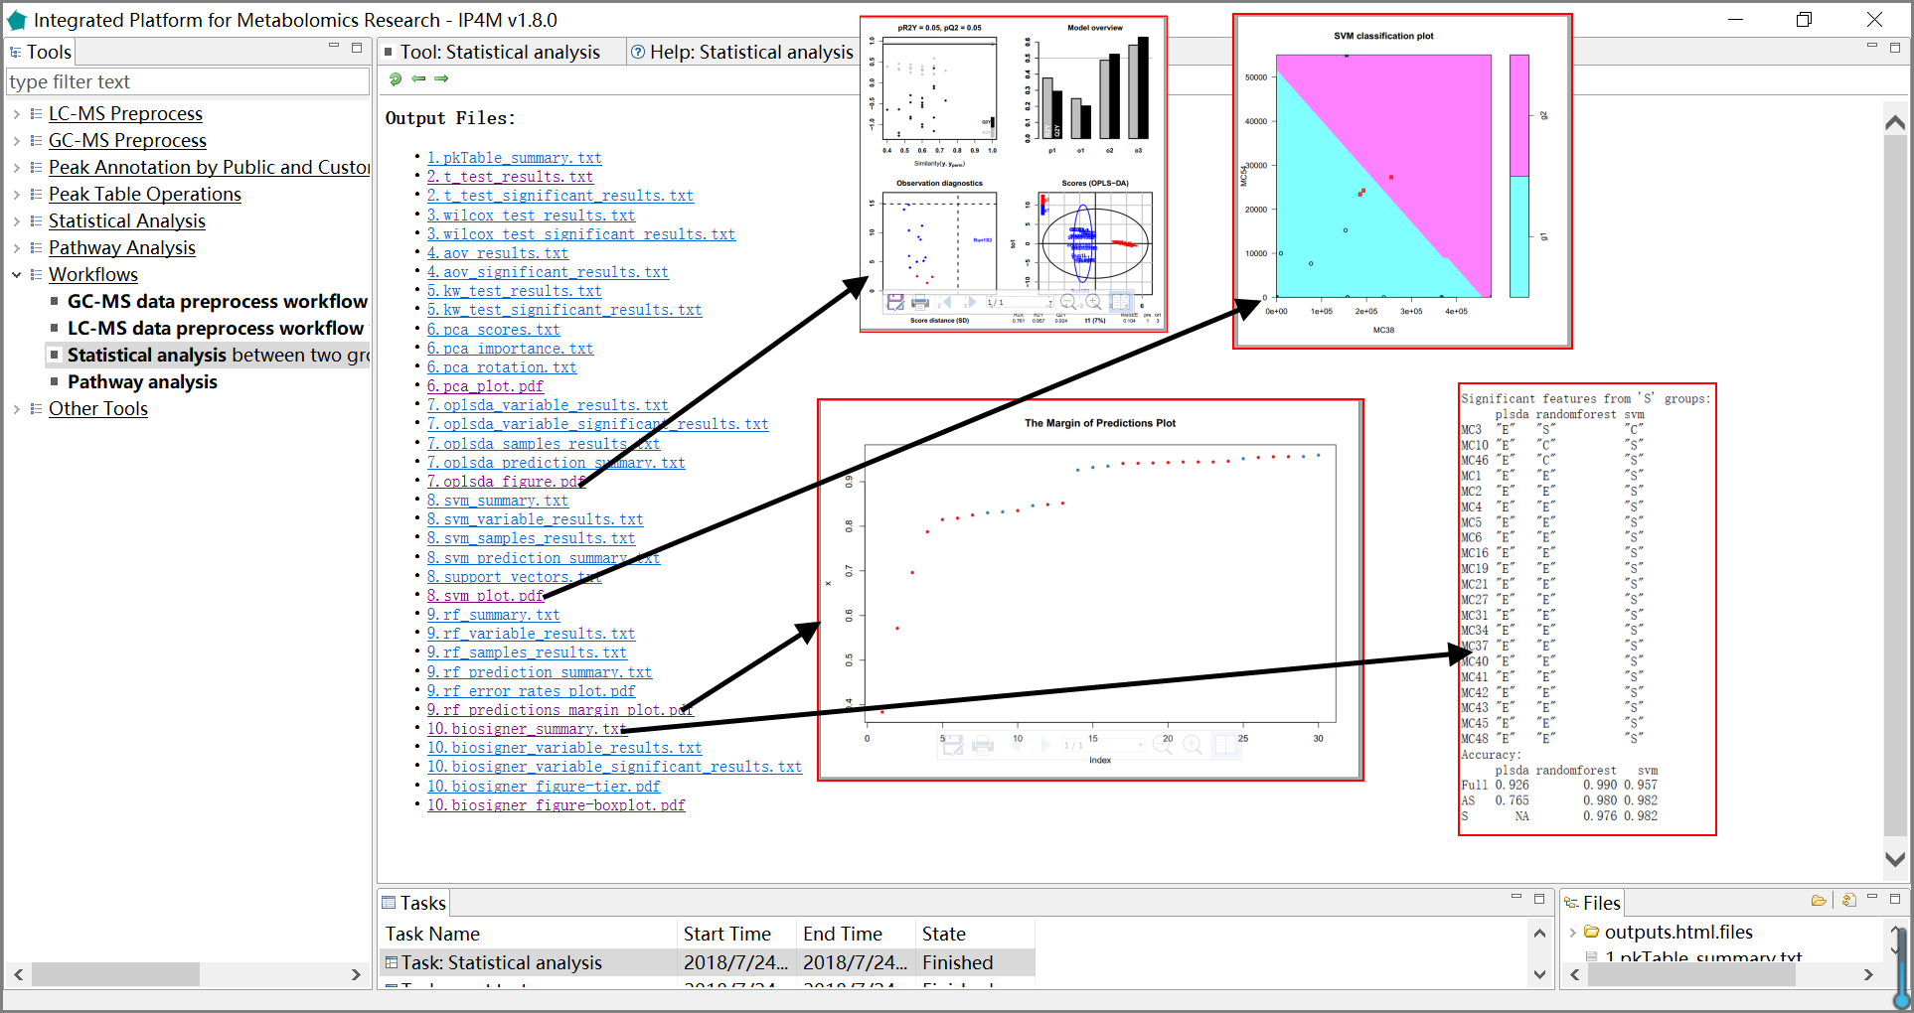

Fig.25 The outputted files and demos (opls-da plot, SVM plot, the margin of prediction plot by RF, and the biosigner summary) of statistical analysis workflow

### 3.6.4 Pathway and enrichment analysis

The tool takes a one-column compound list file as input and performs pathway analysis and enrichment analysis, including compounds ID mapping, KEGG pathway, and enrichment analysis. KEGG pathway libraries with ~1600 pathways are the knowledgebase for this tool which covers 21 species (human, mouse, rat, cow, chicken, zebrafish, arabidopsis thaliana, drosophila, malaria, etc.). The enrichment analysis performs metabolite set enrichment analysis for human and mammalian species. The analysis is based on 8 libraries containing ~6300 groups of biologically meaningful metabolite sets collected primarily from human studies.

**Input files:**

A one-column compound list file in text format.

**Output files:**

'compounds_idmapping.txt ', compounds annotation result.

' pathway_results.txt ', KEGG pathway enrichment analysis result.

'pathway_results_plot.txt ', KEGG pathway enrichment result visualization diagram.

' enrichment_results.txt ', enrichment analysis result.

' enrichment_plot.pdf', enrichment result visualization diagram.

**Results and visualization:**

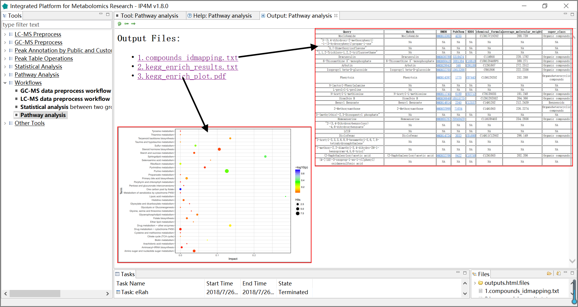Fig.26 The outputted files and visualization of pathway and enrichment analysis workflow

## 3.7 Other Tools

### 3.7.1 Merge LECO CSV files

#### Tool: Merge LECO CSV files on peak table

The tool takes multiple .CSV files as inputs (outputted from the Chromatof software of LECO., USA, reference mode) and merges them to generate a combined peak table file, according to ‘R.T.’, ‘Quant mass’, and ‘Area’. The .CSV files from BT, 4D, and HRT GC-TOF/MS instruments (LECO, USA) are supported.

**Parameter:**

Merge method:

Same mass and RT difference within the cutoff: if same quant mass and rt difference within the cutoff are met, the corresponding compounds of multiple samples is considered as the same one. The “area” values of the same compound will be merged and the name of the compound outputted is the one with the highest frequency of occurrence. For same frequency names, the one with the maximum average strength is taken. If more than one variable (in the same sample) meet the criteria, the largest “area” will be taken.

Same mass and one by one according to RT order: all the inputted files will be sorted by “Quant mass” and “R.T.”, and then merged directly one by one. This option is simple but effective.

**Note:**

This tool is strict to file format. Make sure these columns exist: the retention time column with the name starts with ‘R.T.’, the peak area column named ‘Area’, the quant mass column named ‘Quant Masses’, and the compound name column named ‘Name’. Other columns are also permitted but will not be involved in process. The row number of all the inputted files should be the same.

### 3.7.2 GLM on two groups

#### Tool: GLM on two groups

This tool is the wrapper of the R ‘glm’ function and aims at peak ranking by coefficients of linear regression. Group information is given by a group design file (Tab-delimited text file). The tool is only available for binary classification and the number of groups should be 2.

**Results and visualization:**

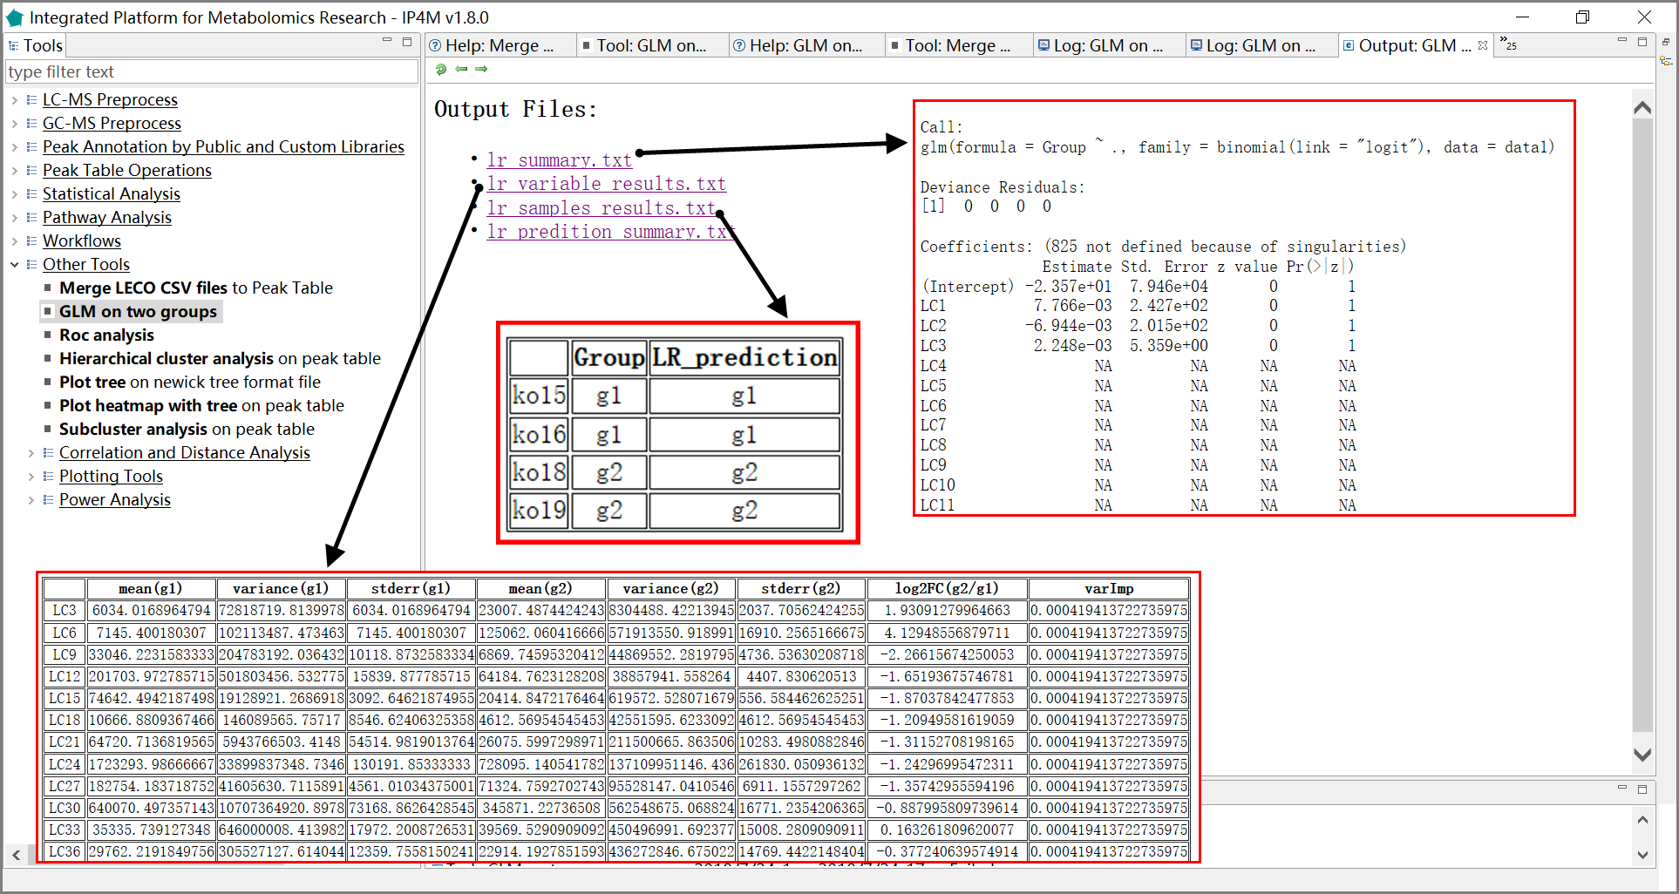

Fig.28 The outputted files and corresponding information of GLM analysis

### 3.7.3 ROC analysis

#### Tool: ROC analysis

This tool takes a peak table file as input and computes ROC curves for every peak.

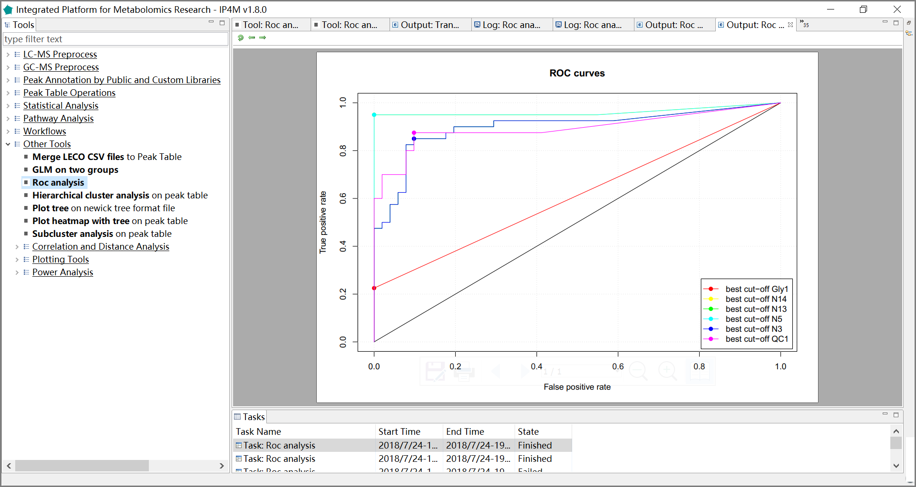

Fig.29 ROC curves of six peaks

### 3.7.4 Hierarchical cluster analysis

#### Tool: Hierarchical cluster analysis on peak table

This tool takes a peak table file as input and performs hierarchical cluster analysis on it.

**Parameter:**

Distance calculate method:

1. Euclidean:

The Euclidean distance between points p and q is the length of the line segment connecting them.

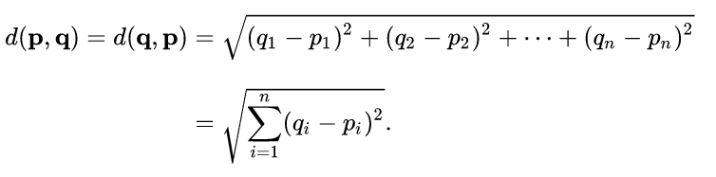

2. Correlation distance:

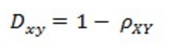

Correlation coefficient: 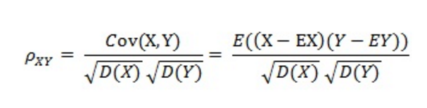

3. Canberra distance：sum (|p_i - q_i| / |p_i + q_i|). Terms with zero numerator and denominator are omitted from the sum and treated as if the values were missing. This is intended for non-negative values (e.g., counts): take the absolute value of the denominator.

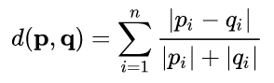

4. Binary distance: The vectors are regarded as binary bits, so non-zero elements are ‘on’ and zero elements are ‘off’. The distance is the proportion of bits in which the only one is on amongst those in which at least one is on.

5. Minkowski distance: The p norm, the pth root of the sum of the pth powers of the differences between the components.

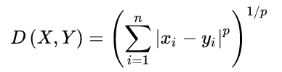

6. Manhattan: Absolute distance between the two vectors.

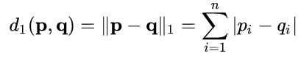

where (p, q) are vectors.



7. maximum distance：Maximum distance between two components of x and y (supremum norm).

Cluster methods:

1. ward: Ward's minimum variance method aims at finding compact, spherical clusters.

2. complete: The complete linkage method finds similar clusters.

3. single: The single linkage method (which is closely related to the minimal spanning tree) adopts a ‘friends of friends’ clustering strategy.

The other methods can be regarded as aiming for clusters with characteristics somewhere between the single and complete link methods.

4. centroid: Method "centroid" is typically meant to be used with squared Euclidean distances.

5. average: The average distance method measures the average distance between each pair of observations

6. mcquitty: It finds the similar cluster.

7. median: Median distance method.

**Results and visualization:**

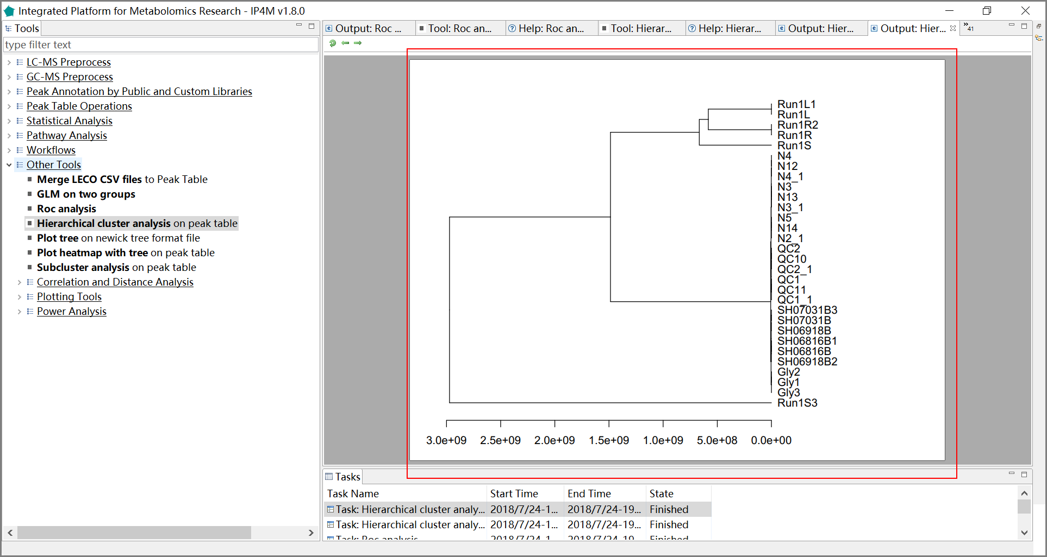

Fig.30 The hierarchical cluster tree plot.

### 3.7.5 Plot tree

#### Tool: Plot tree on Newick tree format file

This tool takes a standard Newick format tree file as input and plots hierarchical tree by phylogram, fan, or cladogram mode.

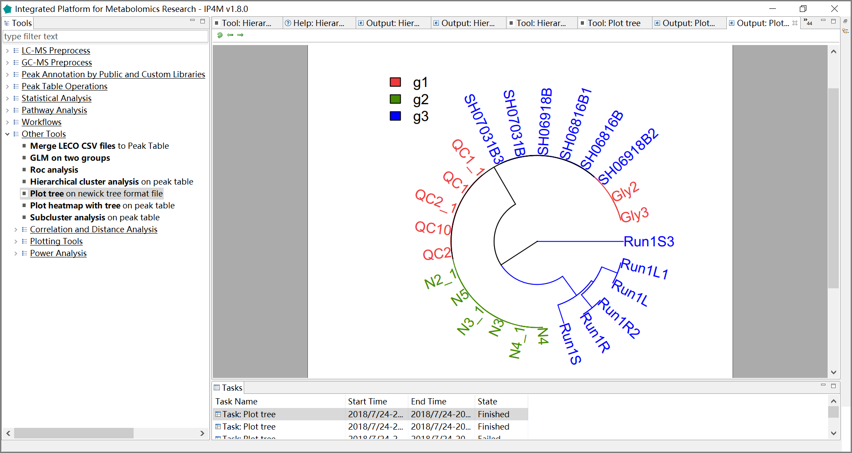

Fig.31 The hierarchical tree plot by fan mode.

### 3.7.6 Plot heatmap with tree

#### Tool: Plot heatmap with tree on peak table

This tool takes a peak table file as input and plots heatmap with clusters on it.

**Results and visualization:**

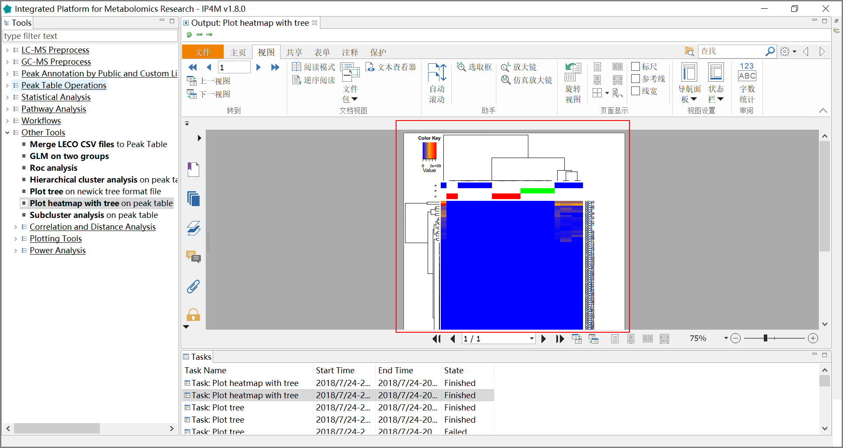

Fig.32 The heatmap with tree in pdf edit box.

### 3.7.7 Sub-cluster expression analysis

#### Tool: Sub-cluster expression analysis on peak table

This tool takes a peak table file as input and performs cluster analysis on it. The metabolites are classified into several groups (clusters) according to their distance or variation similarity.

**Parameter:**

Distance calculate method:

1. Euclidean:

The Euclidean distance between points p and q is the length of the line segment connecting them.



2. Correlation distance:



Correlation coefficient:



3. Canberra distance: sum (|p_i - q_i| / |p_i + q_i|). Terms with zero numerator and denominator are omitted from the sum and treated as if the values were missing. This is intended for non-negative values (e.g., counts): take the absolute value of the denominator.



4. Binary distance: The vectors are regarded as binary bits, so non-zero elements are ‘on’ and zero elements are ‘off’. The distance is the proportion of bits in which the only one is on amongst those in which at least one is on.

5. Minkowski distance: The p norm, the pth root of the sum of the pth powers of the differences between the components.



6. Manhattan: Absolute distance between the two vectors.



where (p, q) are vectors.



7. maximum distance：Maximum distance between two components of x and y (supreme norm).

Cluster methods:

1. ward: Ward's minimum variance method aims at finding compact, spherical clusters.

2. complete: The complete linkage method finds similar clusters.

3. single: The single linkage method (which is closely related to the minimal spanning tree) adopts a ‘friends of friends’ clustering strategy.

The other methods can be regarded as aiming for clusters with characteristics somewhere between the single and complete link methods.

4. centroid: Method "centroid" is typically meant to be used with squared Euclidean distances.

5. average: The average distance method measures the average distance between each pair of observations

6. mcquitty: It finds the similar cluster.

7. median: Median distance method.

**Results and visualization:**

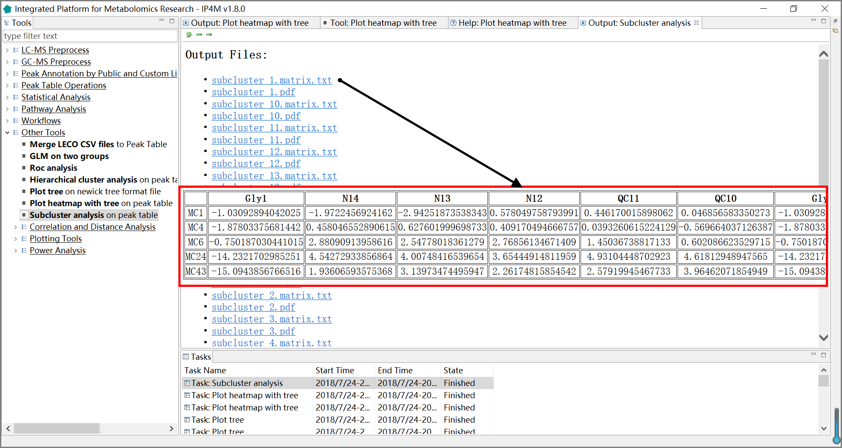

Fig.33 Th outputted files and one matrix of sub-cluster analysis.

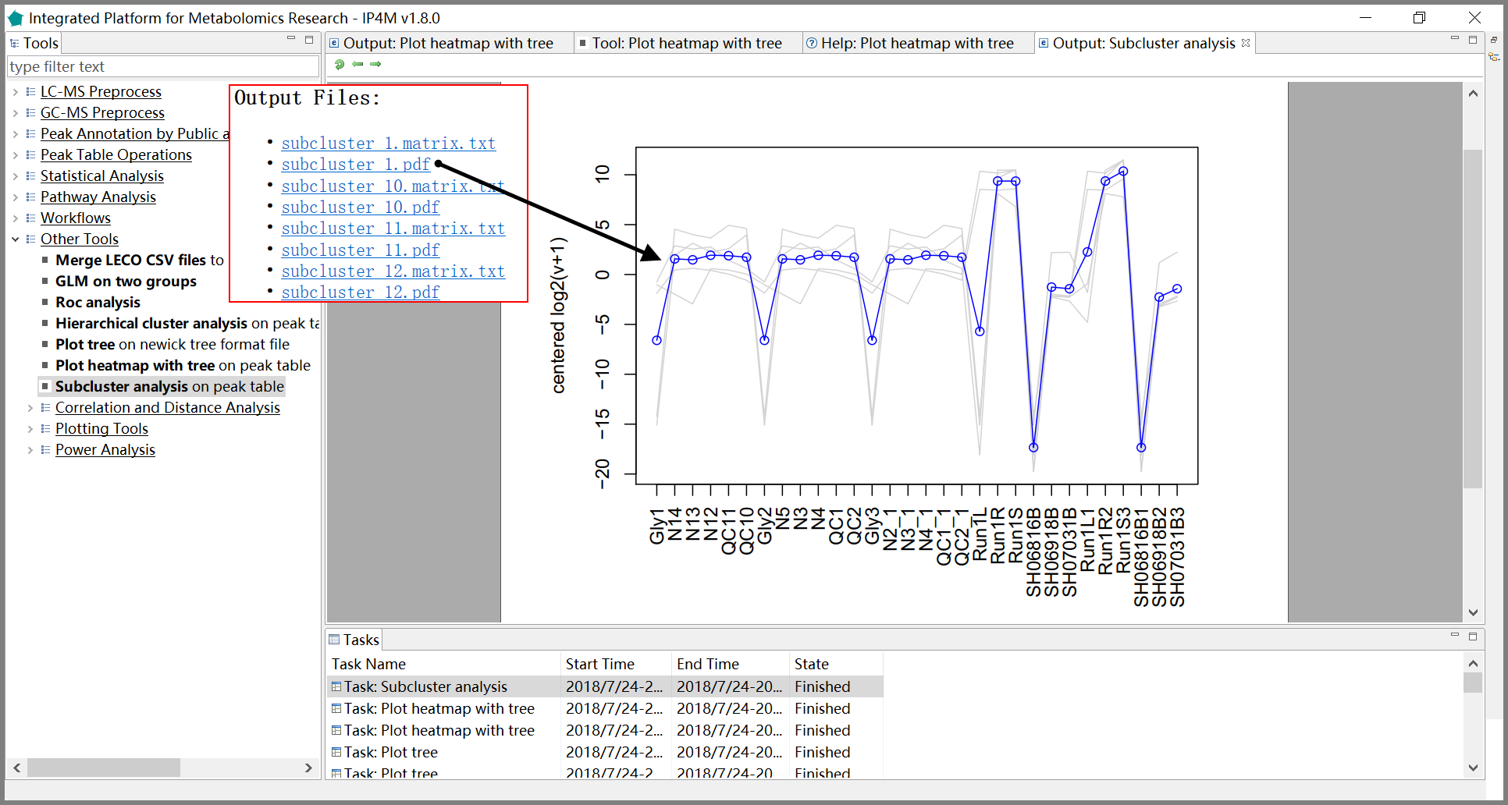

Fig.34 The line chart of sub-cluster1.

### 3.7.8 Correlation and distance analysis

#### Tool: Create sample correlation matrix and make heatmap plot

This tool takes a peak table file as input and performs correlation analysis on it.

**Parameter:**

Correlation methods:

1. Kendall rank correlation:

The Kendall rank correlation coefficient, commonly referred to as Kendall's tau coefficient (after the Greek letter τ), is a statistic used to measure the ordinal association between two measured quantities. A tau test is a non-parametric hypothesis test for statistical dependence based on the tau coefficient.

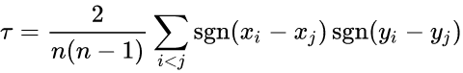

2. Pearson correlation:

the Pearson correlation coefficient, also referred to as Pearson's r is a measure of the linear correlation between two variables X and Y. It has a value between +1 and −1, where 1 is a total positive linear correlation, 0 is no linear correlation, and −1 is a total negative linear correlation.

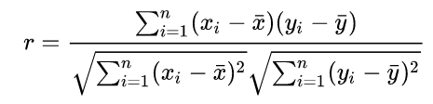

3. Spearman correlation:

Spearman's rank correlation coefficient or Spearman's rho is a nonparametric measure of rank correlation. It assesses how well the relationship between two variables can be described using a monotonic function.

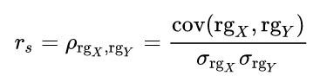

Cluster methods:

1. ward: Ward's minimum variance method aims at finding compact, spherical clusters.

2. complete: The complete linkage method finds similar clusters.

3. single: The single linkage method (which is closely related to the minimal spanning tree) adopts a ‘friends of friends’ clustering strategy.

The other methods can be regarded as aiming for clusters with characteristics somewhere between the single and complete link methods.

4. centroid: Method "centroid" is typically meant to be used with squared Euclidean distances.

5. average: The average distance method measures the average distance between each pair of observations

6. mcquitty: It finds the similar cluster.

7. median: Median distance method.

**Results and visualization:**

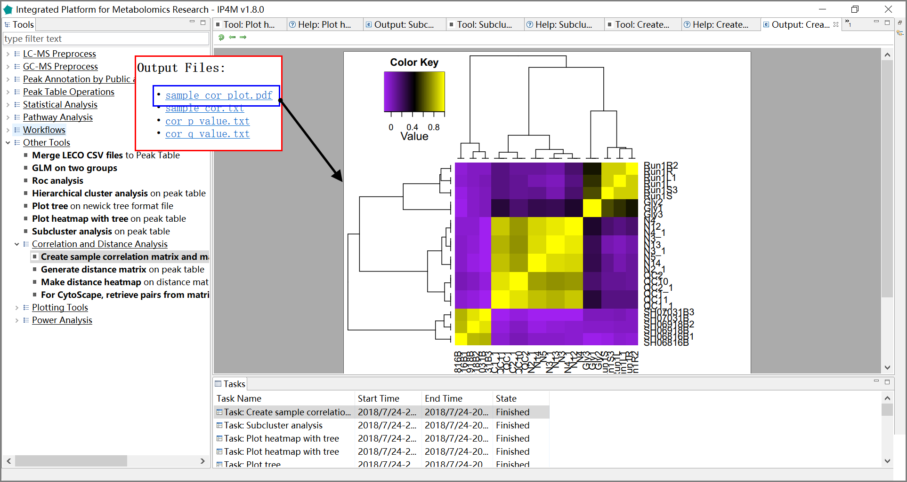Fig.35 The heatmap of correlation analysis

#### Tool: Generate distance matrix on peak table

This tool takes a peak table file as input and generates the distance matrix.

**Parameter:**

Distance calculate method:

1. Euclidean:

The Euclidean distance between points p and q is the length of the line segment connecting them.



2. Correlation distance:



Correlation coefficient:



3. Canberra distance: sum (|p_i - q_i| / |p_i + q_i|). Terms with zero numerator and denominator are omitted from the sum and treated as if the values were missing. This is intended for non-negative values (e.g., counts): take the absolute value of the denominator.



4. Binary distance: The vectors are regarded as binary bits, so non-zero elements are ‘on’ and zero elements are ‘off’. The distance is the proportion of bits in which the only one is on amongst those in which at least one is on.

5. Minkowski distance: The p norm, the pth root of the sum of the pth powers of the differences between the components.



6. Manhattan: Absolute distance between the two vectors.



where (p, q) are vectors.



7. maximum distance：Maximum distance between two components of x and y (supremum norm).

**Results and visualization:**

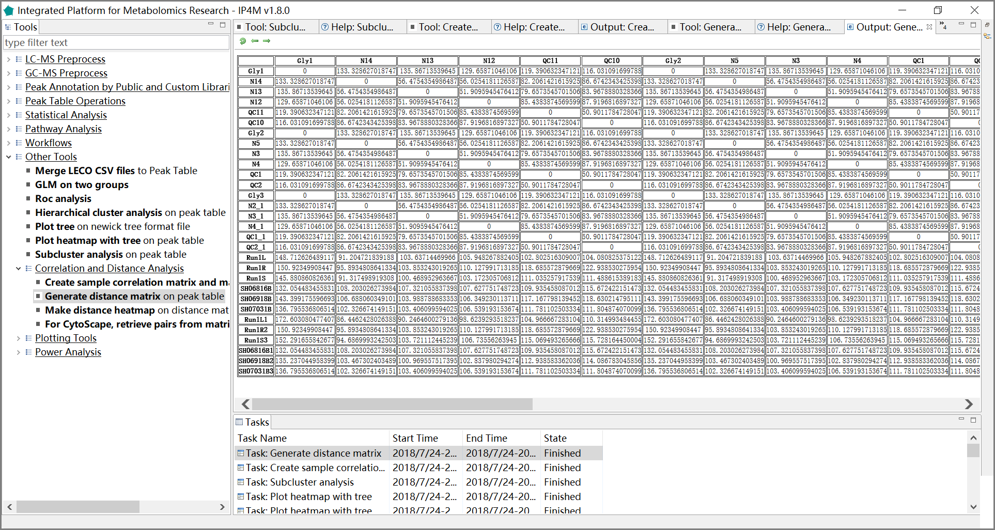

Fig.36 The distance matrix.

#### Tool: Make distance heatmap on distance matrix

This tool takes a distance matrix as input and makes a heat map plot based on it.

**Results and visualization:**

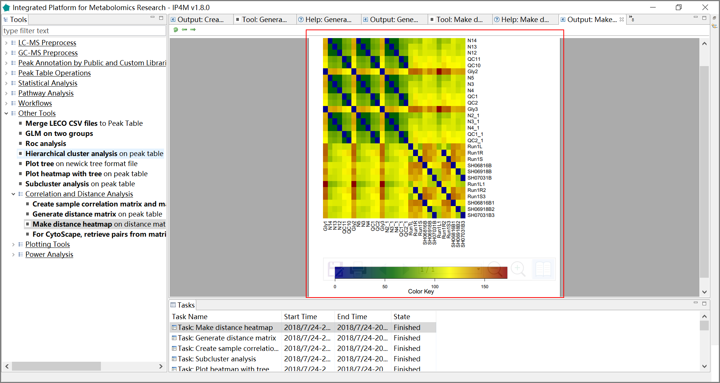

Fig.37 The distance heatmap

#### Tool: For Cytoscape: retrieve pairs from matrix according to specific criterion

This tool retrieves pairs from matrix according to a specific criterion. The result can be imported directly into Cytoscape for network construction.

**Results and visualization:**

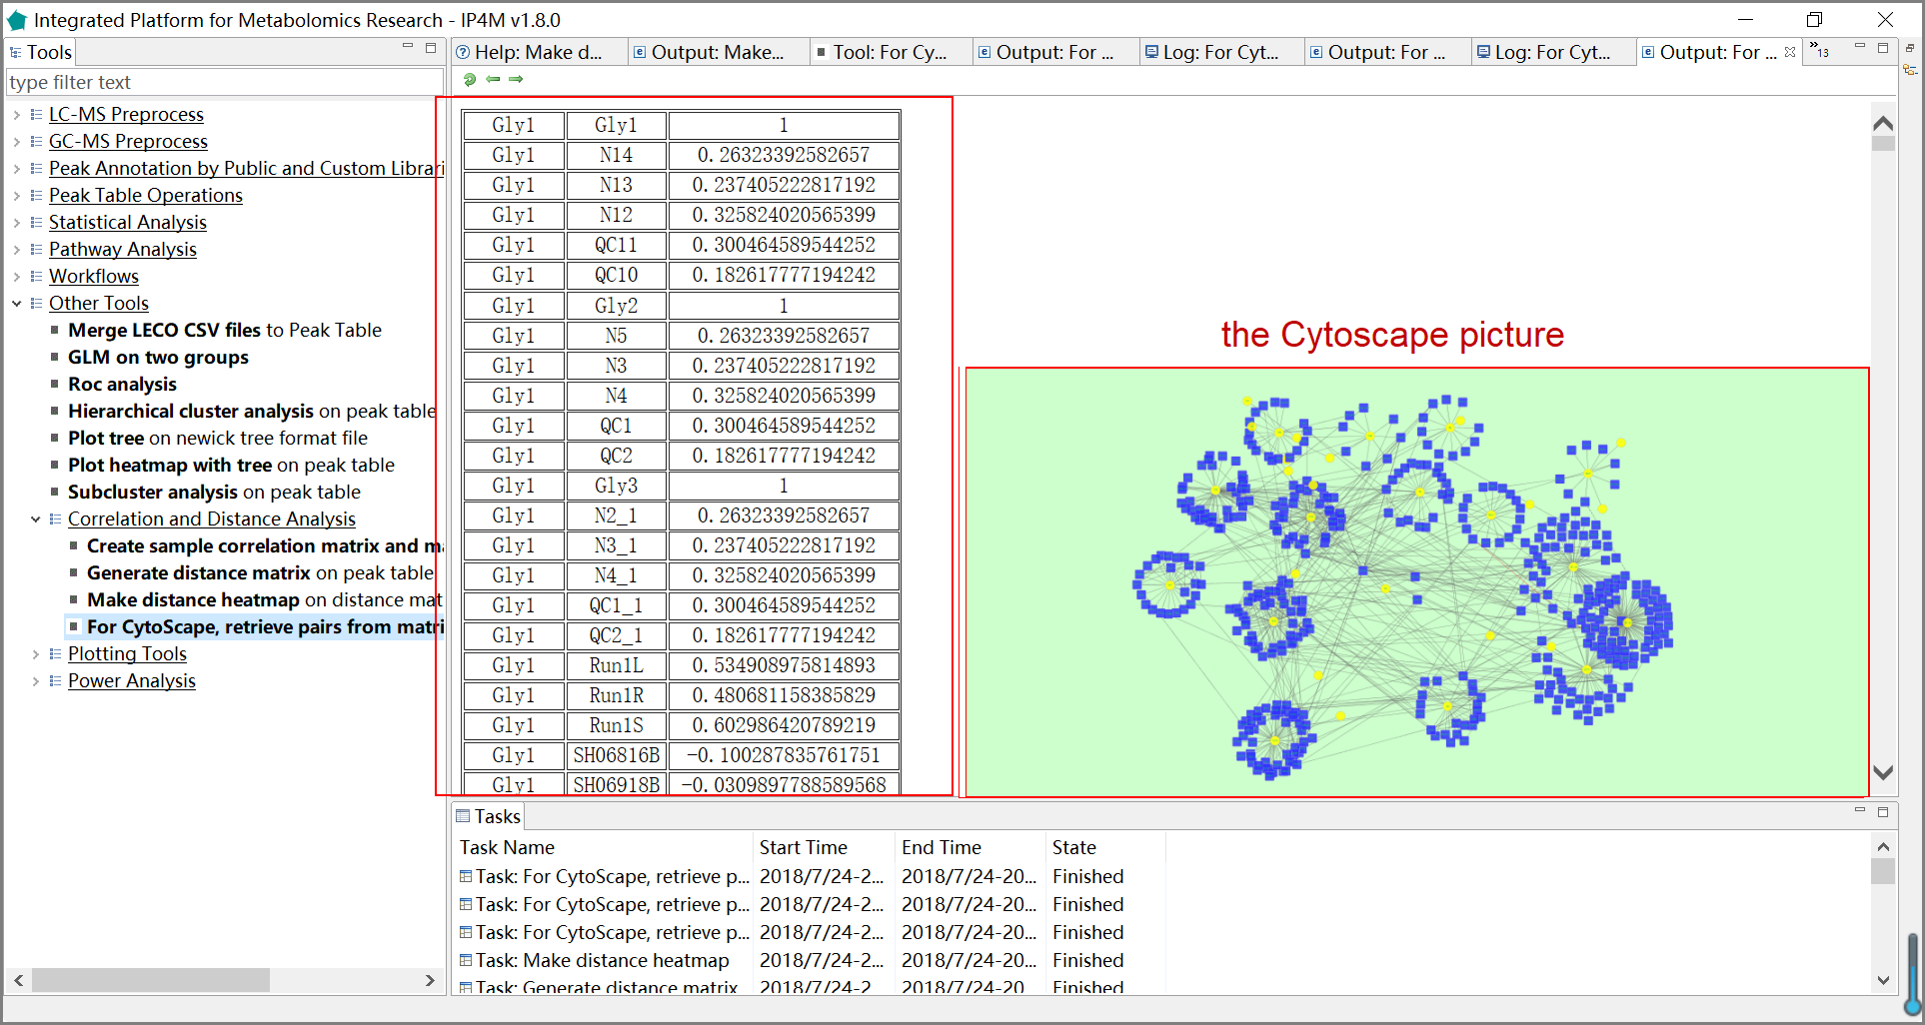

Fig.38 The retrieved pairs for Cytoscape, and the outputted network of Cytoscape.

### 3.7.9 Plotting tools

#### Tool: Plot Venn diagram on metabolites lists

With this tool, you can calculate the intersection(s) of the list of elements. It will generate a Venn plot and textual output indicating which elements are exist in each intersection or are unique to a certain list/group.

**Results and visualization:**

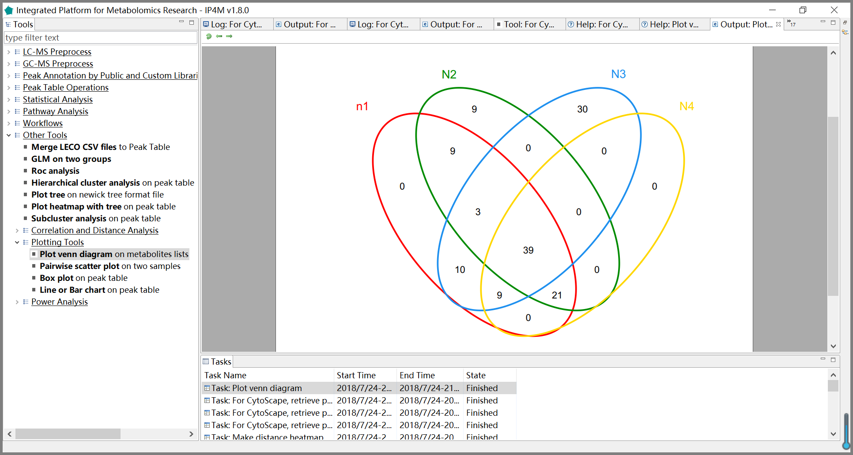

Fig.39 The Venn plot of four groups.

#### Tool: Pairwise scatter plot on two samples

This tool is used for plotting pairwise scatter figures in batch mode. All the scatter plots will be saved in one pdf file.

**Results and visualization:**

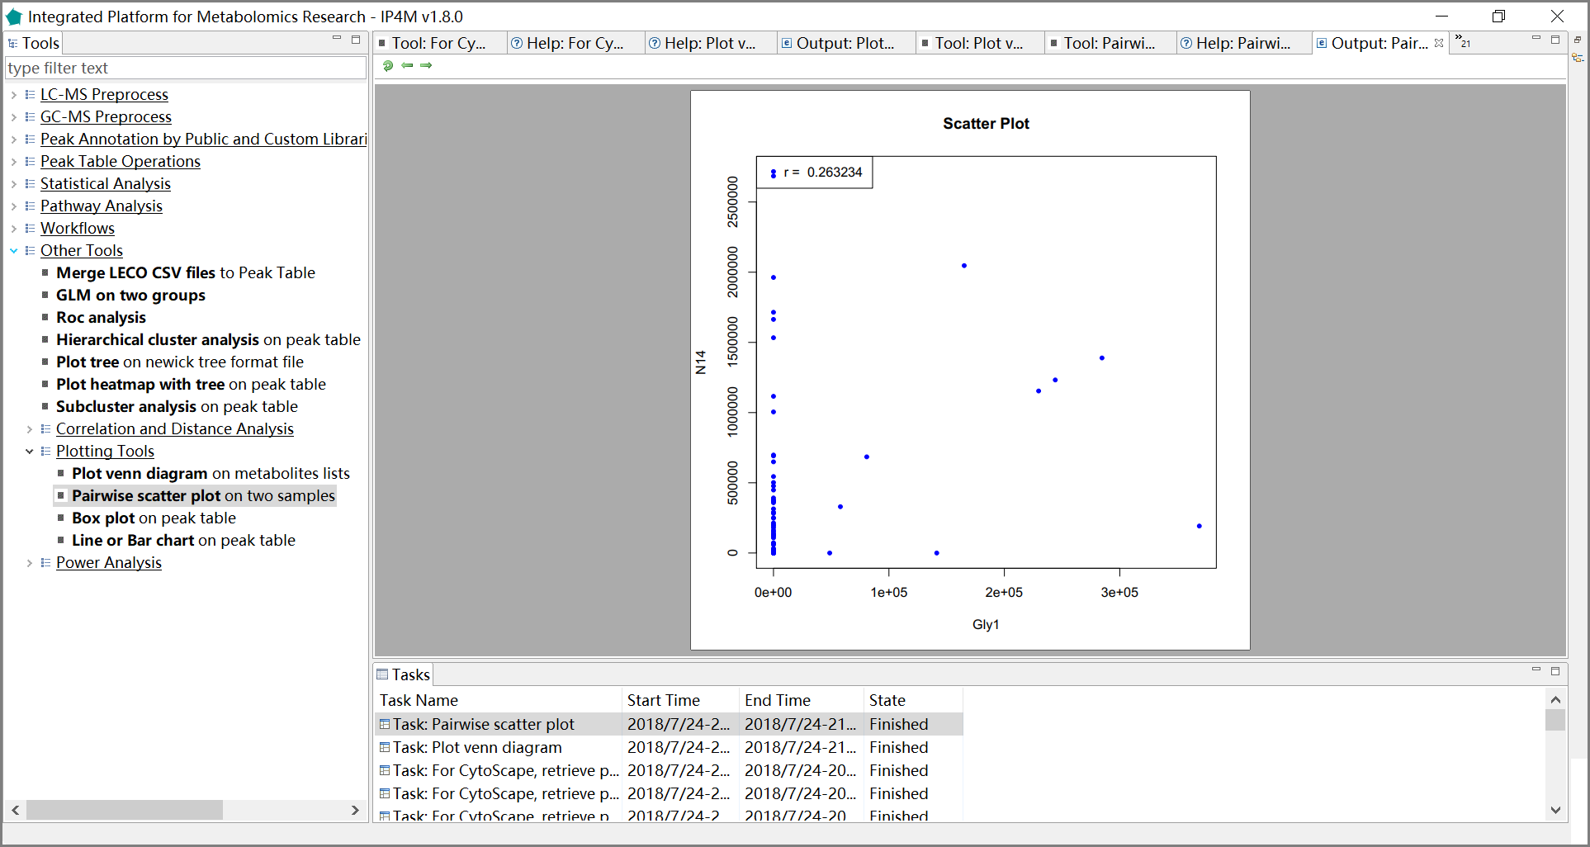Fig.40 The pairwise scatter plot on two samples.

#### Tool: Box plot on peak table

This tool is used for plotting box figures in batch mode. All the box plots will be saved in one pdf file.

**Results and visualization:**

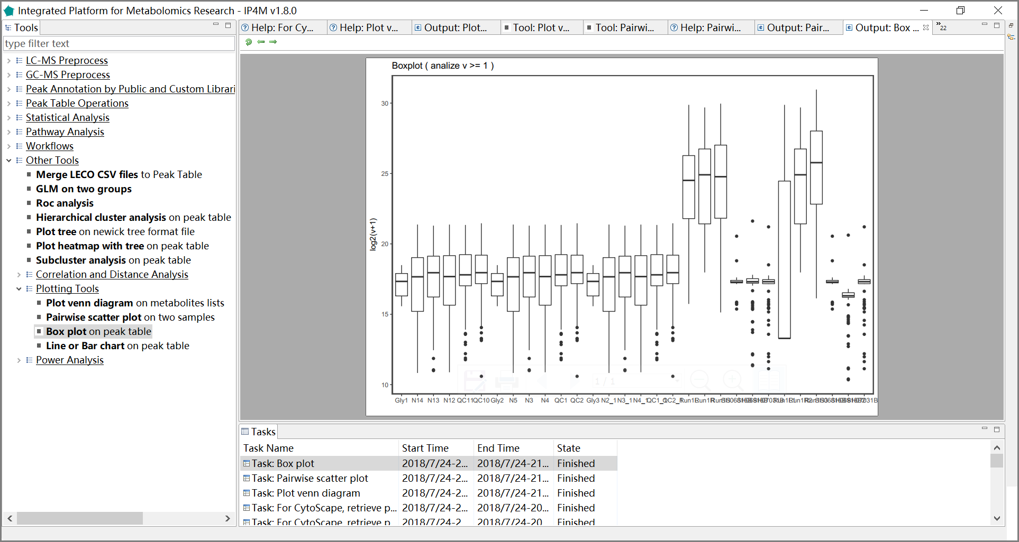Fig.41 The box plot of samples (one box per sample)

#### Tool: Line chart on peak table

This tool is used for plotting line or bar charts in batch mode. All the plots will be saved in one pdf file.

**Results and visualization:**

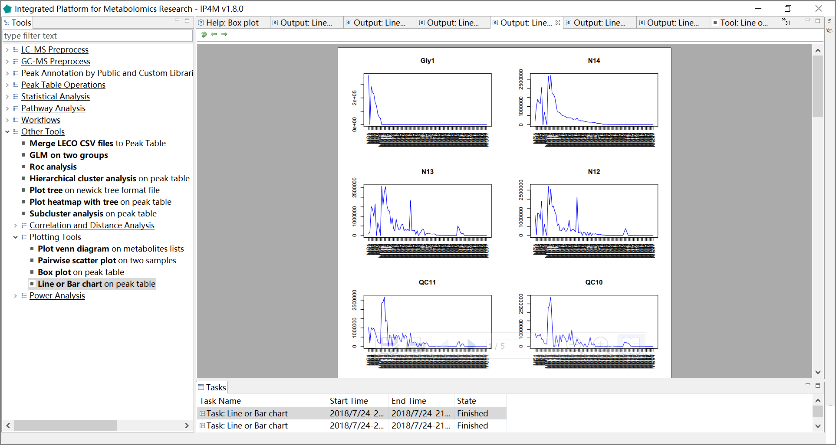

Fig.42 The line charts of samples.

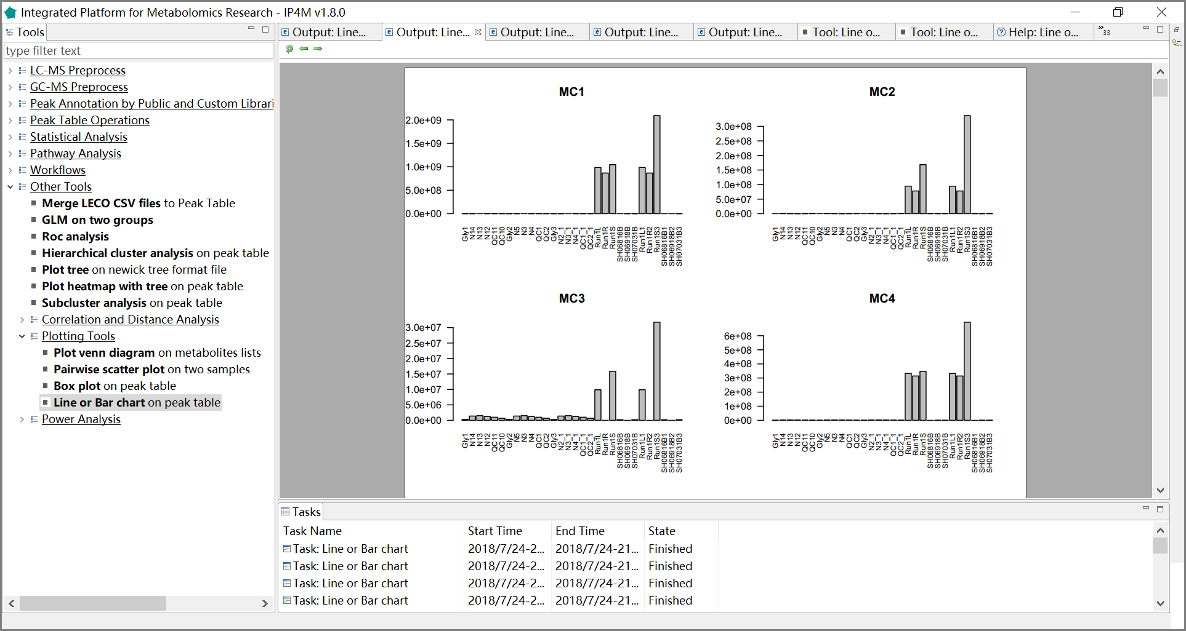

Fig.43 The bar charts of samples.

### 3.7.10 Sample size and power analysis

Sample size and power analysis is helpful to estimate a reasonable sample size before experiments or to evaluate the power of analysis results after experiments.

#### 1) Tool: Pwr.t.test power calculation for t-test (one, two, and paired samples)

For t-tests, the following functions are used:

**pwr.t.test(n = , d = , sig.level = , power = , type = c("two.sample", "one.sample", "paired"))**

where n is the sample size, d is the effect size, and type indicates a two-sample t-test, one-sample t-test or paired t-test. If you have unequal sample sizes, use

**pwr.t2n.test(n1 =, n2=, d =, sig.level =, power = )**

where n1 and n2 are the sample sizes.

For t-tests, the effect size is assessed as

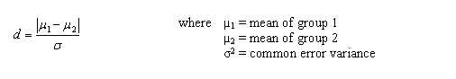

μ1: mean of group1

μ2: mean of group1

σ2: common error variance

Cohen suggests that d values of 0.2, 0.5, and 0.8 represent small, medium, and large effect sizes respectively.

You can specify alternative="two.sided", "less", or "greater" to indicate a two-tailed, or one-tailed test. A two-tailed test is the default.

**Results and visualization:**

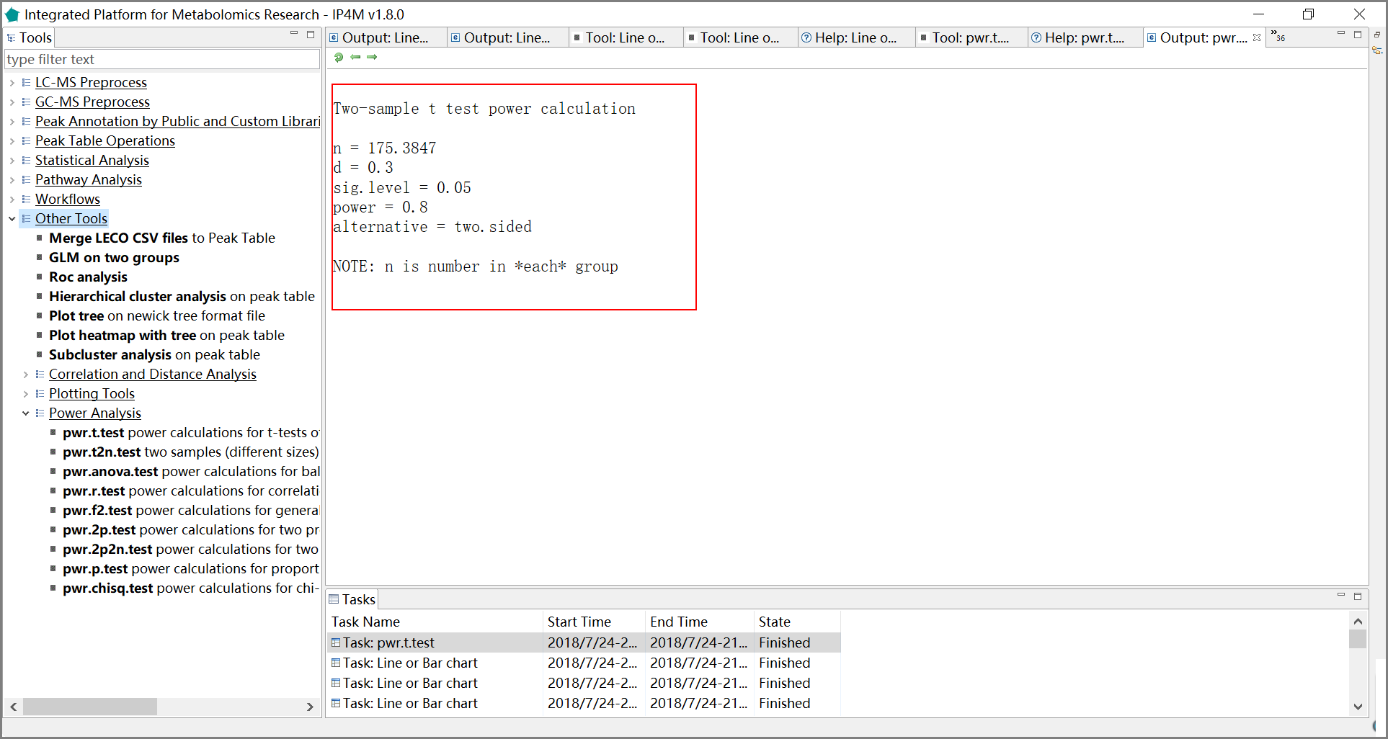

Fig.44 The results of power analysis when two samples t- test is used.

#### 2) Tool: Pwr.t2n.test power calculation for t-test (different sizes)

For t-tests, the following functions are used:

**pwr.t.test(n = , d = , sig.level = , power = , type = c("two.sample", "one.sample", "paired"))**

where n is the sample size, d is the effect size, and type indicates a two-sample t-test, one-sample t-test or paired t-test. If you have unequal sample sizes, use

**pwr.t2n.test(n1 = , n2= , d = , sig.level =, power = )**

where n1 and n2 are the sample sizes.

For t-tests, the effect size is assessed as



μ1: mean of group1

μ2: mean of group1

σ2: common error variance

#### 3) Tool: Pwr.anova.test power calculation for balanced one way ANOVA

For a one-way analysis of variance, the following functions are used:**pwr.anova.test(k = , n = , f = , sig.level = , power = )**

where k is the number of groups and n is the common sample size in each group.

For a one-way ANOVA, effect size is measured by f where

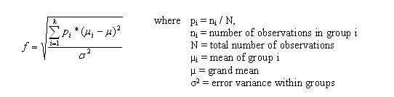

pi=ni / N

ni=number of observations in group i

N=total number of observations

μi= mean of group i

μ=grand mean

σ2= error variance within groups

Cohen suggests that f values of 0.1, 0.25, and 0.4 represent small, medium, and large

effect sizes respectively.

#### 4) Tool: Pwr.r.test power calculation for correlation test

For correlation coefficients, the following functions are used:

**pwr.r.test(n = , r = , sig.level = , power = )**

where n is the sample size and r is the correlation. We use the population correlation coefficient as the effect size measure. Cohen suggests that r values of 0.1, 0.3, and 0.5 represent small, medium, and large effect sizes respectively.

#### 5) Tool: Pwr.f2.test power calculation for general linear model

For linear models (e.g., multiple regression), the following functions are used:

**pwr.f2.test(u =, v = , f2 = , sig.level = , power = )**

where u and v are the numerator and denominator degrees of freedom. We use f2 as the effect size measure.

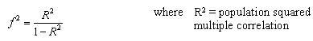

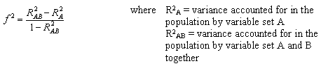

R2 = population squared multiple correlation

R2A = variance accounted for in the population by variable set A

R2AB = variance accounted for in the population by variable set A and B together

The first formula is appropriate when we are evaluating the impact of a set of predictors on an outcome. The second formula is appropriate when we are evaluating the impact of one set of predictors above and beyond the second set of predictors (or covariates). Cohen suggests f2 values of 0.02, 0.15, and 0.35 represent small, medium, and large effect sizes.

#### 6) Tool: Pwr.2p.test power calculation for two proportions (equal n)

When comparing two proportions, the following functions are used:

**pwr.2p.test(h = , n = , sig.level =, power = )**

where h is the effect size and n is the common sample size in each group.

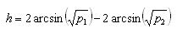

Cohen suggests that h values of 0.2, 0.5, and 0.8 represent small, medium, and large effect sizes respectively.

#### 7) Pwr.2p2n.test power calculation for two proportions (unequal n)

When comparing two proportions, the following functions are used:

**pwr.2p.test(h = , n = , sig.level =, power = )**

For unequal n's

**pwr.2p2n.test(h = , n1 = , n2 = , sig.level = , power = )**

#### 8) Pwr.p.test power calculation for proportions (one sample)

To test a single proportion, the following functions are used:

**pwr.p.test (h = , n = , sig.level = power = )**

For both two sample and one sample proportion tests, you can specify alternative="two. sided", "less", or "greater" to indicate a two-tailed, or one-tailed test. A two-tailed test is the default.

#### 9) Pwr.chisq.test power calculation for the chi-square test

For chi-square tests, the following functions are used:**pwr.chisq.test(w =, N = , df = , sig.level =, power = )**

where w is the effect size, N is the total sample size, and df is the degrees of freedom. The effect size w is defined as

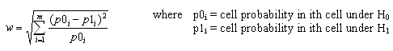

p0i = cell probability in an ith cell under H0

p1i = cell probability in an ith cell under H1

Cohen suggests that w values of 0.1, 0.3, and 0.5 represent small, medium, and large effect sizes respectively.